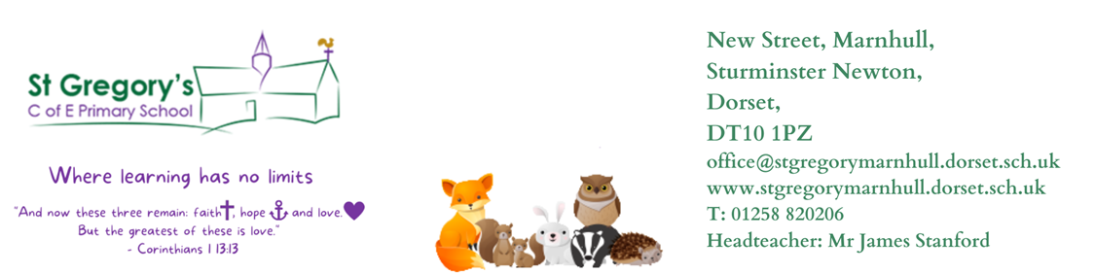

17th April 2024
Dear Parents/Carers,

Welcome back to term 5. I hope you all had a wonderful break and are ready for another exciting term. The children came back full of energy, showing great dedication and enthusiasm towards their learning. This week we have introduced our class book, “The Sheep Pig” and our guided reading will be based on this. As Authors we are learning to write persuasive letters inspired by “The Day the Crayons Quit”.

As Mathematicians we are learning fractions for the first few weeks and then Year 2’s will learn about time whereas Year 3’s will move on to Money and then learn all about time.

Our Curious-city Enquiry is “Why are the food choices we make important to us?” In this enquiry Y3/4 are going to be Scientists and Engineers. They will identify different types of teeth and their functions: humans are omnivores, hence three types of teeth, which are linked to digestion, and, to understand that digestion is how we get nutrition from food and get rid of unwanted food. They will also learn that the food we eat must be balanced where possible and that most human food is ‘prepared’ or ‘processed’ in some way, unlike food eaten by wild animals. They should also understand wild food chains and their Challenge would be to reconsider their perfect meal choices made at the beginning. What would they change and why? Using this, learners will also design an advert or presentation, explaining their meal choices and opinions, with valid scientific justifications.

Year 2’s will be joining Year 1’s and they will be Historians and Engineers this term. Their enquiry is “What did Brunel do for Great Britain?”. They will be learning about people in the past who are considered significant because of the contribution they made to wider society (not necessarily famous); this is called a legacy which many people benefit from in the future as well as at the time of creation. In addition, that to be significant sometimes involves being brave and challenging the status quo and thinking of things in a different way, like I.K.Brunel.

P.E
This half term our P.E sessions will take place on a Monday afternoon and Thursday morning. We are very fortunate to be having sports coaches come into school again to teach Striking and Fielding skills. Please make sure that your child has suitable school P.E kit, hair is also tied back, earrings are either removed or if they cannot be removed are covered with tape.

RE
As philosophers, we will be learning all about Islam: “Muslims’ sense of belonging?”

Reading
Please, listen to your child read as often as you can and ask questions to check their understanding. Encourage them to experience a broad range of stories / texts, such as information books, poetry, newspapers, magazines and online information. New reading books are issued in plastic wallets, and they should be read very fluently as we practise phonics sounds and reading comprehension in school before they bring it home. Children are also encouraged to take a reading book of their choice from the library in school as well.

Home learning
The children will be given their home learning on a Friday this term, and it needs to be returned the following Friday. Their homework will consist of spellings to learn and either a Maths or English worksheet. Our spelling test will be on a Friday morning. Children are also encouraged to regularly use Times Table Rockstars to help them learn their times tables and related division facts. TTRockstars is a great app and I would like to strongly encourage all pupils to access this app at least three times a week. The more they practise the faster they will get with their multiplication and division facts. Children could also compete with their friends, beat each other's scores and be on the leader board aiming to be a Warrior or a Rock Legend etc. Pupils progressing on the ladder will be awarded with certificates at the end of the term.

Any questions or queries, please feel free to contact me.

Yours Sincerely,
Mrs Reddy

Mrs Reddy and all the Badgers Class Team.

