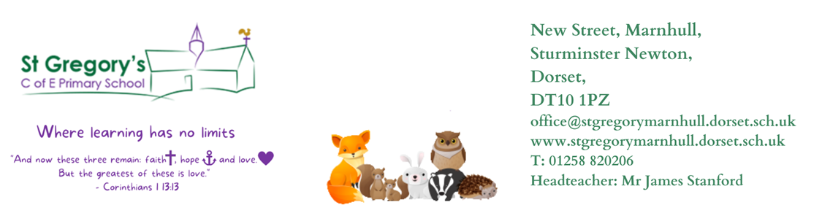

10th June 2024
Dear Parents/Carers,

I hope you all had a fantastic break. And just like that we have reached our final term of this year. The children have worked really hard throughout this year and I am immensely proud of their progress. Thank you all for your continued support and contribution towards our learning.

This week, we have celebrated the school’s 150th anniversary with lots of activities such as creating our self-portraits, dancing, writing poems, creating projects on our future school, the Bishop of Salisbury’s visit as well as a full day experience of being a Victorian.

As Authors we are learning to write a recount on “The Lighthouse Keeper’s Lunch”. Our guided reading will be based on, “The Iron Man”.

As Mathematicians Year 2’s will learn Statistics and the last few weeks on Position and Direction. Year 3’s will be learning Shape and Statistics. It is assessment week from the 17th June, so please continue to practice multiplications, addition and subtraction, time, fractions and all the learning we have done so far.

Our Curious-city Enquiry is “Where does water come from?” In this enquiry Y3/4 are going to be Scientists and Geographers. They will be learning about states of matter, what is the water cycle and how evaporation and condensation takes place. As geographers we will look at the world map for geographical features eg rivers, mountains and learn how to use the 8 points of a compass. Our challenge is to create painted versions of ‘Rivers of the World’ banner. Then the last three weeks will be based on a new enquiry “what should you flush down the loo?” We will continue to learn that water is a finite resource in an infinite cycle, and that it can be wasted as well as stored, although storage means it is effectively taken out of the ‘cycle’. The challenge is to design and display ‘The only things that should go down the loo!’ posters.

Year 2’s will be joining Year 1’s and they will also be Scientists this term. Their enquiry is “What is home?”. They will learn that animals need a home for protection and live in an environment suited to them, close to food sources and shelter. Animals are generally scared of humans and therefore we do not see them that often, but we still know they are there through clues they left behind. In addition, they should know that there can be many different types (species) of the same group (genus) of animals.
In the last few weeks, they will be learning about “how do plants grow near me?” Plants usually have four ‘parts’ and that they need light, water, and nutrition (not ‘food’, that is a term used for animal nutrition). Plants have seeds which grow into new plants. They live in a region on a continent which is one of seven continents surrounded by different oceans.

P.E
This half term our P.E sessions will take place on Thursday morning. Sports coaches will continue to come into school again this term and teach athletics. Please make sure that your child has suitable school P.E kit, hair is also tied back, earrings are either removed or if they cannot be removed are covered with tape. Also, as the weather is getting warmer, we are going to make use of our swimming pool. We will have whole class swimming sessions on a Monday and Thursday. Please remember your swimming kits (swimming suits, goggles, hat and towel) with earrings removed or else you will not be allowed to swim.

RE
As philosophers, we will be learning all about Judaism: “What is the best way for a Jew to show commitment to God?”

Reading
It is lovely to see a great improvement with our reading and children are moving onto chapter books of their choice from the library. Please listen to your child read as often as you can, ask questions to check their understanding and record in their diary. New reading books are issued in plastic wallets, and they should be read very fluently as we practise phonics sounds and reading comprehension in school before they bring it home. Please look after these books, as we will have to make a charge if lost or spoilt.

Home learning
We will continue to get new home learning on a Friday, and it needs to be returned the following Friday. Their homework will consist of spellings to learn and either a Maths or English worksheet. Our spelling test will be on a Friday morning. Please encourage children to regularly use Times Table Rockstars to help them learn their times tables and related division facts.

Any questions or queries, please feel free to contact me.

Yours Sincerely,
Mrs Reddy

Mrs Reddy and all the Badgers Class Team.

