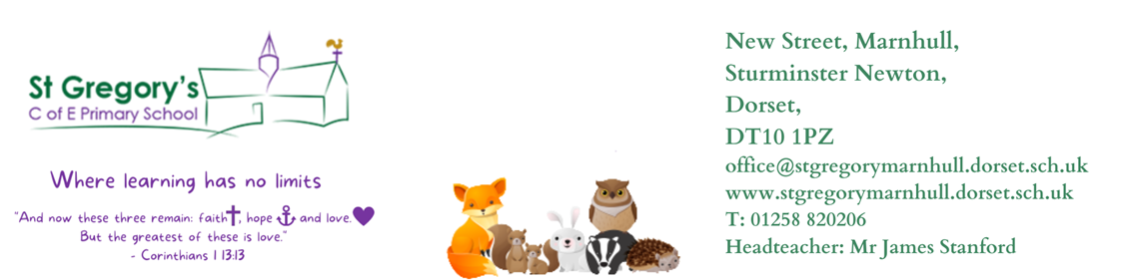

6th November 2023
Dear Parents/Carers,

Welcome back, I hope you all had a wonderful half term break and had an amazing time with family and friends. Badgers Class have come back to school, positive and ready to learn. We will continue to read our class book, “Fantastic Mr Fox” and our target is to write a non chronological report about foxes, then we will innovate it to a new animal before we do our own independent report. We will also be exploring shape poems later on this term. Our guided reading is also based on this book.

We have started our Maths learning on Addition and Subtraction. Year 2’s will be moving on to shape later on and Year 3’s will be moving on to Multiplication and Division.

I am delighted to inform you that Year 3 and 4 has completed their last enquiry on What is Sound? Their challenge was to showcase their learning to the rest of the school and they were amazing. Our enquiry for this term is “Why do we live here?”. We will be Geographers, Historians and Artist this half term. We will have the opportunity to learn mapping skills, human and physical geography such as rivers, mountains, settlements, landuse etc and learn locational knowledge with the use of Atlases, globes and maps. We will also be going for a walk around the village next week to explore human and geographical features as well as find any changes that have occurred overtime. Their challenge at the end of the enquiry is to demonstrate their learning through a “now” and “the” display/presentation. The historical civilisation studied will support their understanding of why their local area has been inhabited today. Drawings of their local area alongside a double page spread or similar of their ancient civilisation will enable learners to orally explain to an audience Why we live here?.

Year 2’s will be joining Year 1’s and their Enquiry is: “How can we Help?” They will be an Artist and Musician. Last week we had volunteers for a special visits from the local food bank and the Shoebox Charity ‘House of Opportunity’ to learn about what they do and why they do that. The children’s final challenge at the end of their enquiry is to create a story board depicting an act of kindness and perform using sound effects. We will be using an empty shoebox to create a backdrop if anyone has any spare please send them in with your child.

P.E
This half term our P.E sessions will take place on a Monday morning and Friday afternoon. We are very fortunate to be having sports coaches come into school again to teach us Ball skills. Please make sure that your child has suitable school P.E kit, hair is also tied back, and earrings are either removed or, if they cannot be removed, covered with tape.

Reading
Please can children continue to bring their individual reading books into school daily. Reading is highly valued as we know that it underpins a child's education and inspires children's vocabulary and imagination helping them to be more resilient, independent and creative learners. Reading is a skill required in all areas of life; therefore, children must be supported to develop such an important skill. Please, listen to your child read as often as you can, preferably three times a week. The banded reading book is also issued, and children are also encouraged to have a reading book of their choice in school. Children are encouraged to use the book review sheets in our story corner to recommend a book to their friends.

Home learning
Thank you to all the parents who have been amazing in supporting with homework and spelling. I issue new homework every Monday, they need to be returned the following Monday. Our spelling tests will be on a Monday morning too. Children are also encouraged to regularly use Times Table Rockstars at home to help them learn their times tables and related division facts. This will help them in all areas of their Maths.

Any questions or queries, please feel free to contact me.

Yours Sincerely,
Mrs Reddy

