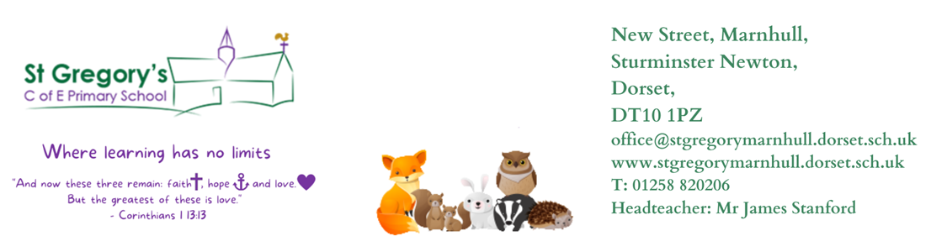

4th January 2024
Dear Parents/Carers,

Happy New Year and welcome back. I hope you all had a wonderful Christmas break with family and friends. It was lovely to see happy faces, all very enthusiastic and showing a positive attitude towards their learning. This week we have introduced our class book, “George’s Marvellous Medicine” and we will be learning to write instructions. Our guided reading will be based on another book, “Hodgeheg”. Year 2’s are learning all about Money and then they will be learning Multiplication and Division facts. Year 3’s are learning Multiplication and Division facts then they will move on to a length and perimeter topic (Year 3).

Our Curious-city Enquiry is “How can we switch off?” In this enquiry (Y3 /4) are going to be Scientists and Geographers. They will explore and construct simple electrical circuits, learn about conductors and insulators, learn where electricity energy comes from (solar, wind etc), identify appliances that use electricity and many more. Their challenge is to create a leaflet about saving energy and they will also be an apprectice electrician and create a full circuit using light, buzzer or by having a challenge with two or more lights within the circuit. This will be timed and certificates awarded for being the quickest electrician.

Year 2’s will be joining Year 1’s and they will be Geographers this term. Their enquiry is “How are schools the same”. They will be learning about physical and human geography features, make connections with other schools and identify how they are similar. Their challenge is to create a ‘comparing’ poster that explicitly describes similarities between the two settings.

P.E
This half term our P.E session will take place on a Thursday afternoon. We are very fortunate to be having sports coaches come into school again to teach net and wall games. Please make sure that your child has suitable school P.E kit, hair is also tied back, earrings are either removed or if they cannot be removed are covered with tape. This term we are also lucky to have Forest School /Pound on Mondays. This will be scheduled on rota between the other classes. Please remember to bring your Forest School kit every third Monday. Badgers will have their first forest school on the 15th January. Ping will be sent as reminder.

RE
In RE, we will be learning all about Judaism and how important it is for Jewish people to do what God asks them to do?

Reading
Please can children continue to bring their individual reading books into school daily. Reading is highly valued as we know that it underpins a child's education and inspires children's vocabulary and imagination, helping them to be more resilient, independent and creative learners. Reading is a skill required in all areas of life; therefore, children must be supported to develop such an important skill for life. Please, listen to your child read as often as you can, encouraging them to experience a broad range of stories / texts, such as information books, poetry, newspapers, magazines and online information. The banded reading book is also issued, and children are encouraged to have a reading book of their choice from the library in school as well.

Home learning
The children will be given their home learning on a Friday this term, and it will need to be returned the following Friday. Their homework will consist of spellings to learn and either a Maths or English worksheet. Our spelling test will be on a Friday morning. Children are also encouraged to regularly use Times Table Rockstars to help them learn their times tables and related division facts. TTRockstar is a great app and I would like to strongly encourage all pupils to access this app at least three times a week. The more they practise the faster they will get with their mulitiplication and division facts. Children could also compete with their friends, beat each others scores and be on the leaderboard aiming to be a Wannabe or a Rock legend etc.

Any questions or queries, please feel free to contact me.

Yours Sincerely,
Mrs Reddy

Mrs Reddy and all the Badgers Class Team.

