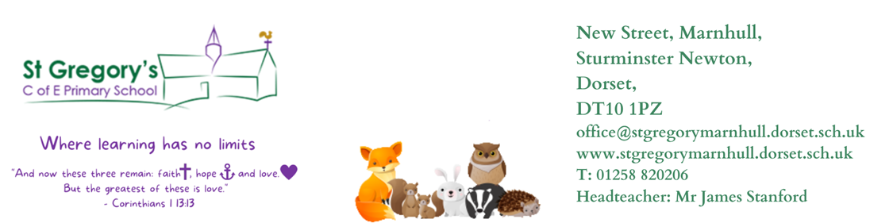

6th November 2023
Dear Parents/Carers,
I hope you all enjoyed a restful holiday and are ready for another busy half term as we run up to Christmas.
Enquiry
This half term, years 5 and 6 will be exploring the enquiry question - who were the greater engineers: the Victorians or the Ancient Britons? We will marvel at great engineering feats, learn how structures are built and strengthened, explore women in STEM, look at the life and works of Brunel and go on a trip to Stonehenge (details to follow).
With Mrs Reddy, year 4 will be geographers in their enquiry question: why do we live here? They will be exploring: maps, human settlement and population patterns and landscape changes through time.
PE
Monday – Gymnastics
Friday – Netball
Please ensure that the children have suitable school PE kit, that long hair is tied back and that earrings are either removed or, if they cannot be removed, covered with tape.
Homework
New homework will be given out on a Friday and expected to be returned completed the following Friday. Homework will consist of spellings to learn, which will be tested on Friday afternoon, and a Maths or English activity. It is also expected that all children, particularly year 4, regularly practise their times tables at home. Times Tables Rockstars is a brilliant, engaging way for them to practise on a device at home. If your child is unsure of their password and pin for TTRS please let me know.
Reading
Please continue to listen to your child read at home as often as you can, encouraging them to experience a broad range of texts such as: information books, poetry, newspapers, magazines and online information as well as stories. Listening to your child read will not only help their reading and comprehension skills but also their vocabulary and writing across the curriculum. Children should be heard read aloud at least three times a week and this should be recorded in their reading record (year 4s).
Good luck to year 5 and 6 on their residential to PGL next week! I hope they have a wonderful time and I am very much looking forward to seeing the pictures and hearing their stories from the trip when they return.
If you have any questions, concerns or queries then please reach out to me.

Yours sincerely,
Mrs Brown
Foxes Class Teacher

