St Gregory’s C E Primary School

New Street, Marnhull, Dorset. DT10 1PZ.
Tel: 01258 820206
e mail: office@stgregorymarnhull.dorset.sch.uk
www.stgregorymarnhull.dorset.sch.uk

Headteacher: Mrs Debbie Field

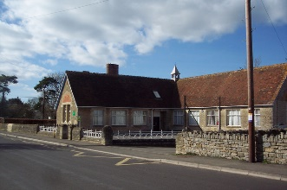

“Where learning has no limits”

12th November 2020

Dear Parents/Carers,

Our topic this term is ‘Stargazers’ where we will be learning about the solar system. To help you explore this topic at home, there is a knowledge organizer a home learning ideas sheet being sent home with your child today. If you have any photos, artefacts, books or do some work about this subject, we would love to see them and show them to the class.

Our P.E. days are still Tuesdays and Fridays. Please could your child come to school in their PE kit that day, including trainers and have a waterproof coat and spare pair of shoes. Please check the weather for those days and dress accordingly ie. Tracksuit trousers if cold.

Remember your child will need to bring in a fruit or vegetable snack for break as well as a named water bottle filled with water each day because the water fountain is out of action.

Homework – This consists of reading (to an adult at least 3 times a week), spellings and times tables.
Your child has been given a reading record book in which to record their reading at home and school. When you hear your child read, don’t forget to sign the record. It is your child’s responsibility to ensure that it is in school everyday along with their current book.
Each child will have weekly spellings on a Monday to learn, ready for a test on the Friday.
Times tables are linked to Times table rock stars – your child should have a username and password – please encourage them to play at home as it is a way to learn.

If you have any concerns, please don’t hesitate to contact the office by phone or email.
`
Kind regards
Beth Cheeseman

“I have come that they may have life, life in all its’ fullness” John 10:10

