St Gregory’s C E Primary School

New Street, Marnhull, Dorset. DT10 1PZ.
Tel: 01258 820206
e mail: office@stgregorymarnhull.dorset.sch.uk
www.stgregorymarnhull.dorset.sch.uk

Headteacher: Mrs Debbie Field

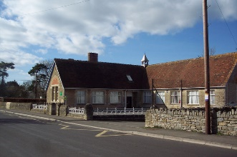

“Where learning has no limits”

1st October 2020

Dear Parents/Carers,

It is so lovely to have everyone back and after three weeks we are settling down into the new routines. Badger Class is lucky to be supported again this year by Mrs Heasman and Mrs Irvine.

Our topic this term is ‘Pharoahs’ where we will be learning about daily life in Ancient Egypt. If you have any photos, artefacts or books about this subject, we would love to see them and show them to the class.

Our P.E. days are Tuesdays and Fridays. Please could your child come to school in their PE kit that day, including trainers and have a waterproof coat and spare pair of shoes. Please check the weather for those days and dress accordingly ie. Tracksuit trousers if cold.

Remember your child will need to bring in a fruit or vegetable snack for break as well as a named water bottle filled with water each day because the water fountain is out of action.

Homework – This consists of reading (to an adult at least 3 times a week), spellings and times tables.
Your child has been given a reading record book in which to record their reading at home and school. When you hear your child read, don’t forget to sign the record. It is your child’s responsibility to ensure that it is in school everyday along with their current book.
Each child will have weekly spellings on a Friday to learn, ready for a test on the next Friday.
Times tables are linked to Times table rock stars – your child should have a username and password – please encourage them to play at home as it is a way to learn.

If you have any concerns, please don’t hesitate to contact the office by phone or email.

Kind regards
Beth Cheeseman

“I have come that they may have life, life in all its’ fullness” John 10:10

