The Daily Mile in Hedgehog Class

All our children take part in 10 minutes of exercise each day – it is called the daily mile; it is very inclusive and it should be noted children don’t have to run a whole mile.

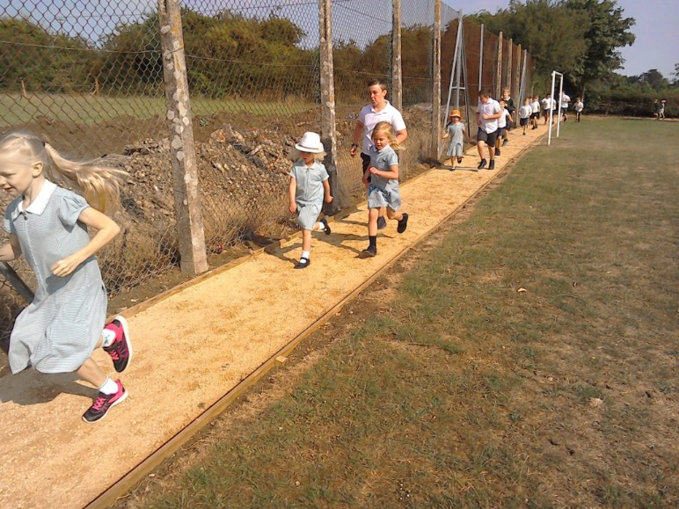
Thanks to St Gregory’s cinder running track around the school field we have a weather resistant area to use all year round.

The children use it as a time to exercise together often gossiping all the way round (better outside than in class time). Once they have completed their 10 minutes, they are fully awake and ready for their days learning.

More information for parents can be located at this website: The Daily Mile

