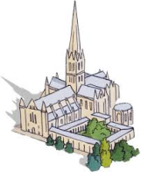 St Gregory’s Unique Pupil Offering
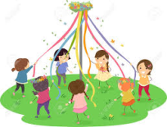
At St Gregory’s we believe that we celebrate our own special identity through the unique experiences we offer to our children. We have developed a rich and varied menu of enhancement opportunities to engage and recognise individuality.
Our unique experiences are offered sometimes as a whole school, classes or year group, as appropriate. Over time a number of these offerings have become ‘tradition’ and the children very much feel they are an important part of life at St Gregory’s.

Throughout their time with us children will experience:
- London Parliament visit
- London theatre show
- Salisbury Cathedral Leavers service
- Outdoor residential
- Pantomime
- Santa Walk around community
- Performing to the community
- Raising and caring for our animals
- Maypole dancing
- Church services to the community
- Remembrance service delivered by the children
- Whole school Church Christmas performance
- Age appropriate visits to local area

