St Gregory’s SEN in a nutshell – Spring 2 – 2022

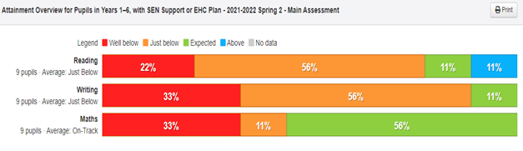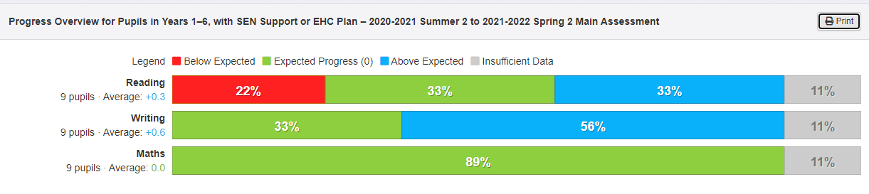
Strengths of St Gregory’s SEND

Quality first teaching using adaptions / scaffolding

Impact of intervention sessions

Birmingham Toolkit to
identify targets

Relationships with parents

Knowledge of the children and their families

Individual teaching / support

Systems for tracking

Early identification

Support for our SEND children at St Gregory’s:
Provision provided through:
High quality first teaching – using adaptions / scaffolding
Ensuring staff deliver high quality interventions / catch up – close the gap
Reading support
Speech & language support - Makaton
Maths intervention
Nessy
TT Rockstars
Learn to move
Effective Marking & Feedback
WEB sessions for social, emotional, behaviour needs
Develop learning of ‘whole child’

Priorities
Closing of the gap for our SEND children

Ensuring staff are continually kept up to date with SEND CPD

