**Phonics in Hedgehog Class**

Phonics is the teaching of letter sounds to help children learn to read. Words are made up from small units of sounds called phonemes. Phonics teaches children to be able to listen carefully and identify phonemes that make up each word, thus helping children to learn to read and spell.

Most schools in the UK now teach reading through phonics. The reason phonics is so widely used is that research shows it works! That is why the official school curriculum says that children need to be taught to read using a systematic phonics system.

In Hedgehog Class phonics is part of every day. We teach differing levels to EYFS and Year 1.

***EYFS (Early Years Foundation Stage) Phase 2 Phonics***

Two days are spent revising sounds previously taught as well as learning new sight words. The remaining three days are spent learning new sounds.

We practise hearing the sound, saying it, writing it and then blending by reading CVC words with that focus sound in. What are CVC words I hear you cry!

***CVC words are three letter words that follow a consonant/vowel/consonant pattern. CVC words are considered the simplest words for emerging readers to decode by blending the three sounds together***

We have learnt the following sounds so far:

s, a, t, p i, n, m, d, g, o, c, e, h, r, u, b, l, f, j,

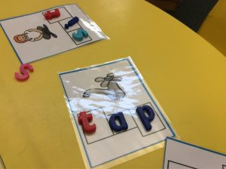We will play blending games and use magnetic letters to create some new CVC words.

***Phonics – Year 1***

During the Autumn term the children have been consolidating the Phase 3 Letters & Sounds diagraphs. Over the next few weeks, we shall start looking at the alternate sounds to these. The link below will help explain our learning in phonics for the rest of the year.

<https://www.youtube.com/watch?v=i3z6AfFd7oM&feature=youtu.be>

Below is a link to the Gov.uk website and provides further reading for parents on phonics.

[Learning to Read Through Phonics](https://assets.publishing.service.gov.uk/government/uploads/system/uploads/attachment_data/file/194057/phonics_check_leaflet_2013_.pdf)