[St Gregs – Where learning has no limits (stgregorymarnhull.dorset.sch.uk)](https://stgregorymarnhull.dorset.sch.uk/) 1st July 2024

Dear Parents / Carers,

We are nearly at the end of the school year and I would like to congratulate all the children for what they have achieved over the last three terms. They have been working very hard and our latest round of assessments shows the progress they have made. With many new ways of learning (Curious-city, Little Wandle Phonics, The Write Stuff English programme and Jigsaw RE to name but a few), they have shown themselves adaptable and enthusiastic learners. We have three weeks left and I am sure they will all enjoy the events, activities and learning still to come this term.

**PRAISE ASSEMBLY**

I am looking forward to presenting many children with certificates and awards on the last day of term. This special assembly will acknowledge the hard work the children have made all year, highlighting their achievements and hopefully inspiring others to be adventurous, creative, musical, sporting or any other activity they wish to be involved in. **May Assembly:**

**Y6 AWARDS:**

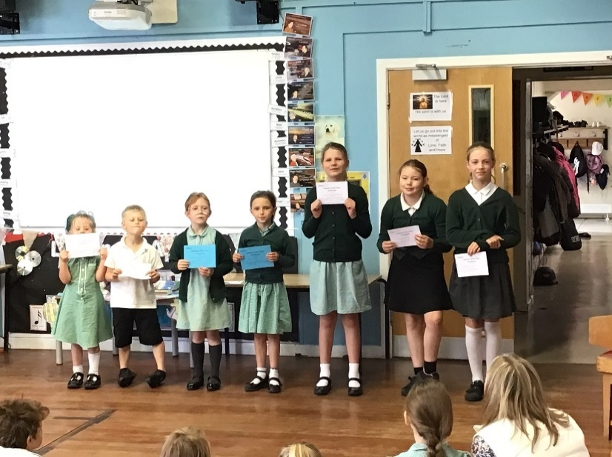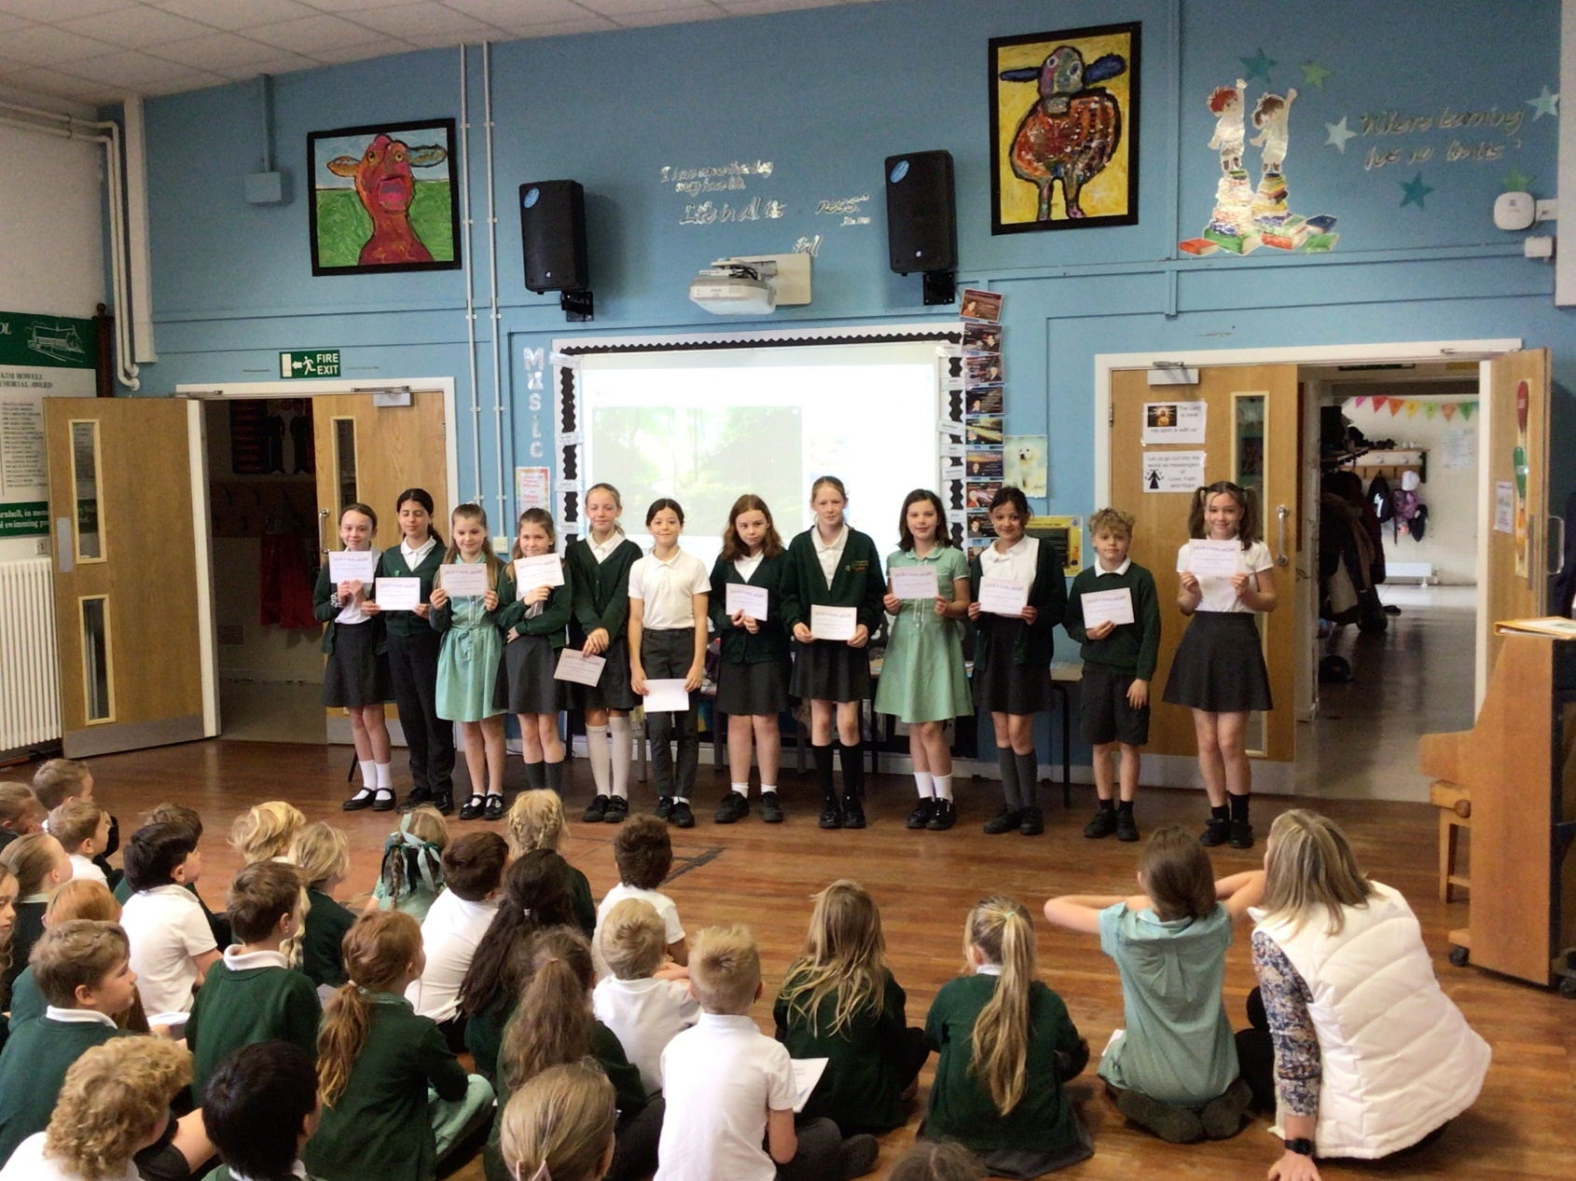**LEARNERS OF THE TERM:**

**100% ATTENDANCE:**

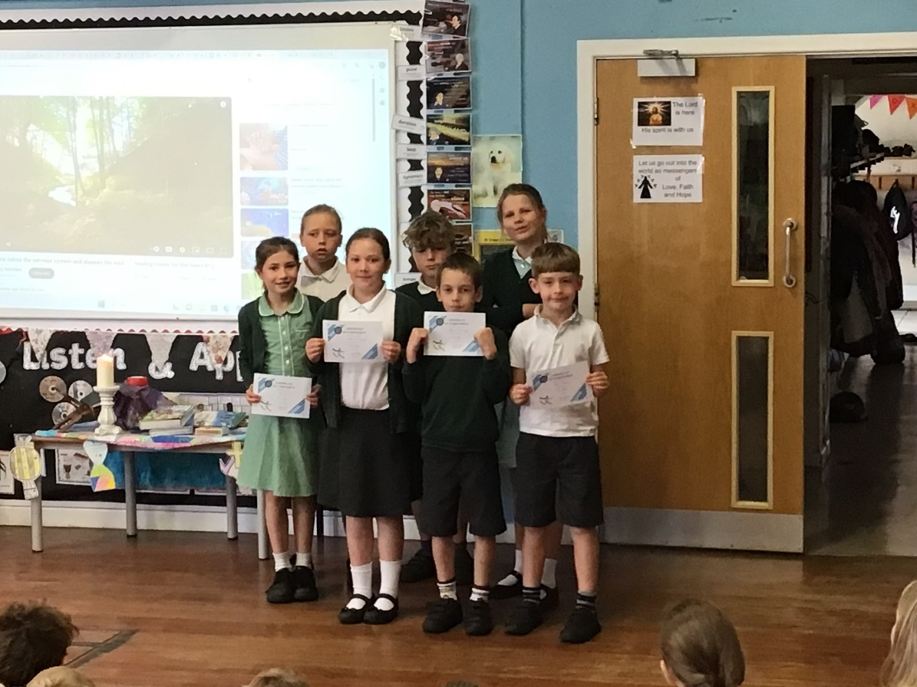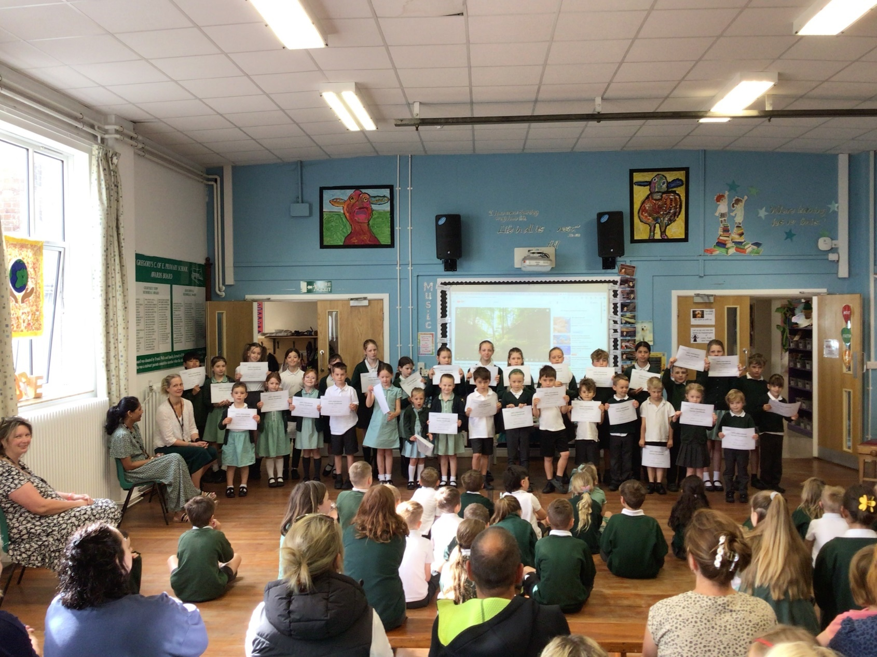

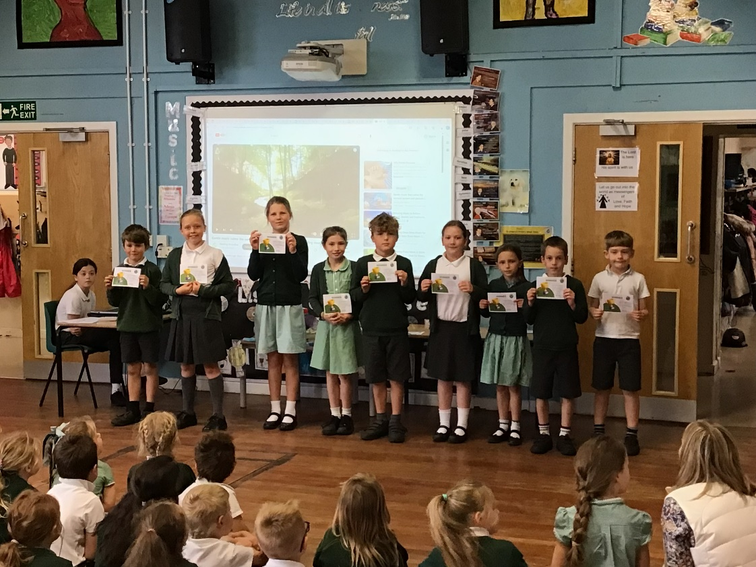

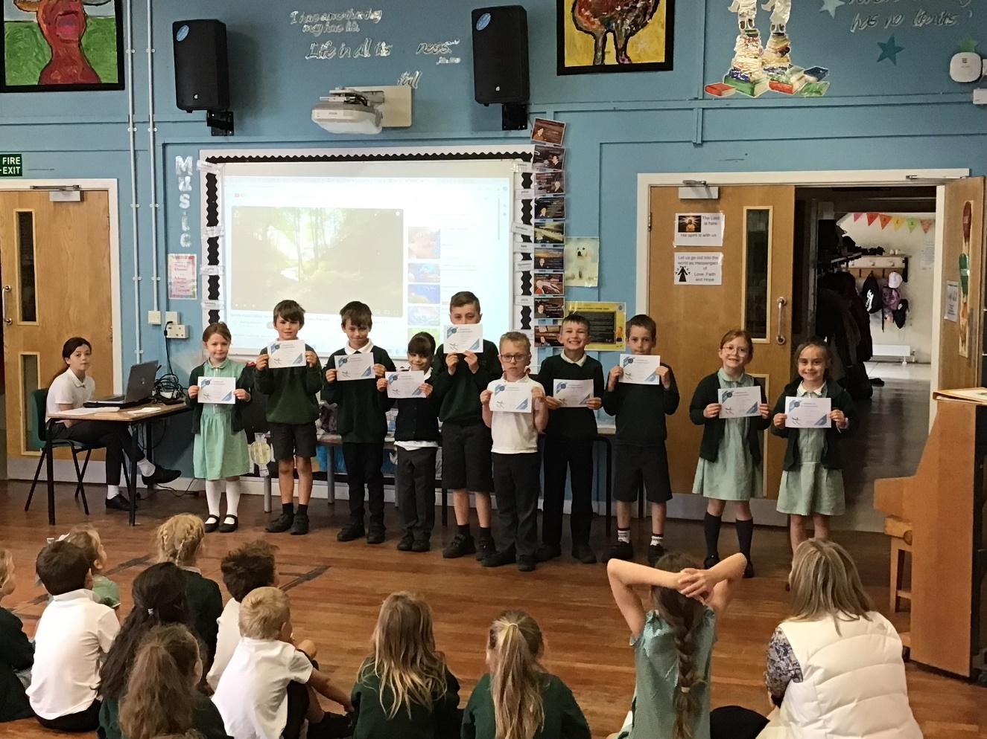 **SPORTS EVENTS:**

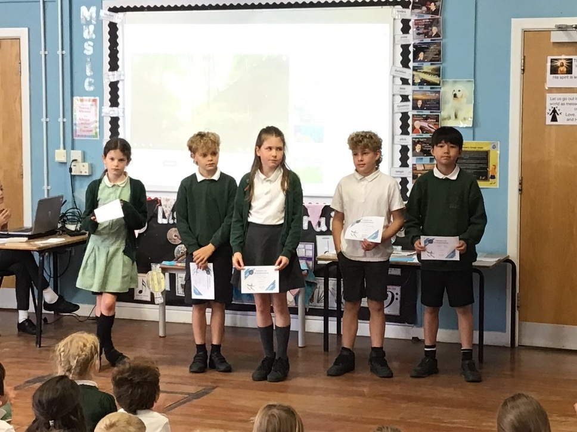

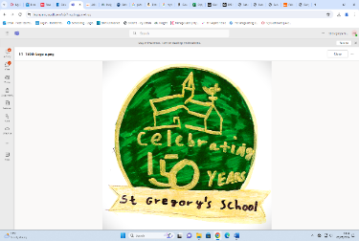**SCHOOL ANNIVERSARY –** Our celebrations during the first week back this half term were a great success, with the visit from Bishop Stephen, the Bishop of Salisbury, being an occasion to remember. He had a good tour of the school, chatting with the children, and gave a wonderful address at the service in the church organized by Revd Gaenor. On his return to school, he blessed the brilliant new mural painted by Mrs Andrews and, despite not being a cake-eater, made sure he took a piece of the spectacular and delicious celebration cake baked by Mrs Bosley. The rest of the week was full of variety, with visitors to the school talking about their time at St Gregory’s. The Book Fair was well-supported, raising some additional funds for us to expand our range of books in the school library, and the Art Gallery proved a popular attraction. Everyone went to great effort dressing up for the Victorian Day; I think most children are pleased they are at school in the 21st Century…

The Fun Day, shared with Jungle Hut, was a lovely day. The children’s stalls and other attractions were very popular and raised almost £700 for each organisation. The dogs were well-behaved, the band in the evening was brilliant, the barbecue very popular and Mr Collen very wet! Everyone seemed to enjoy themselves hugely, and it was good to have a joint event with the PreSchool.

**Sports Events**

Children from Key Stage 2 joined with others from across the Gillingham area to take part in the Area Athletics competition at Yeovil Athletics Arena. Our children were very busy with running, jumping and throwing events and we came back with a brilliant haul of medals – I look forward to presenting them at the final Praise Assembly of the year.

Our Tennis Team had great success at their tournament at Port Regis and as winners were invited to Bryanston School to play against teams from all across North Dorset. They were given some expert coaching, played a range of matches and tried out the new sport of Pickleball.

During this year, we have taken advantage of Bath Rugby’s Community support programme through our Tag Rugby after school club. This culminated in a brilliant roadshow where all year groups had a chance to develop their rugby-playing skills and hopefully gain a taste for the game.

**Other Events**

Our Year 6 pupils were lucky to be offered places at the Salisbury Diocese Leavers’ Service in Salisbury Cathedral in June. Joining in with other Year 6 pupils from church schools across Dorset and Wiltshire in such a magnificent setting was a real experience for them, and I am sure they will remember this occasion for many years.

The whole school had a brilliant day organised by the Dorset Rural Music School where they learnt the skills of Samba drumming. Foxes Class had, of course, already had a good introduction to the style through their music lessons with Mr Colwell earlier in the year, so the concert at the end of the day showed some real talent. Well done to all the children for their performance.

This year, most of our new Reception intake have been coming into school to join Hedgehogs Class on Wednesday afternoons. This has been an excellent way for them to become familiar with the setting, to get to know the current Reception children and to know the adults in the school. We have had a number of more structured transition sessions so when we come to Move-Up Day this week, they should be raring to come in.

Children in Year 6 have also been engaging in transition activities, with staff from Gillingham and Sturminster secondary schools coming here to meet the children. These arrangements all help to give the children confidence for tackling the next stage in their education journey

**HEDGEHOGS’ OUTSIDE AREA**

You may remember plans being shared for the development and improvement of the Early Years outdoor learning environment. Those plans had originally involved resurfacing and re-roofing the space between Hedgehogs Class and the office. Since then, the school has joined the Pickwick Academy Trust, a move which has brought us visitors from schools across the Trust and specialists in a range of educational matters. One of these is a specialist in Early Years, and has helped us refine our plans to develop the area. We have been advised that the biggest drawback to Hedgehogs’ outdoor area was that it had to double as a walkway for the rest of the school. We were also told that for our environment, there was already plenty of covered space for the outdoors, and there was no need for a safety surface.

As a result, we have shelved the earlier plans and have now reconfigured the space to create a separate walkway for the school. This has enabled us to ensure continuous provision can take place either side of a playtime or another class’s PE without disturbance. The rest of the money, earmarked from funds raised by the M12K over the last few years, will be spent providing high quality, long-lasting and mainly naturally made learning resources so our children have the best opportunity to excel in fine and gross motor control, being imaginative and expressive, creating with materials and building relationships.

**SWIMMING POOL**

Payment request sent 25/6/24 £10 per child - voluntary contribution towards the school pool. This will greatly assist with running costs of pool chemicals, which are used up each time the children swim, and to help towards a new pool cover - this is no longer functional as it is fragile and unrepairable, now ripped and letting in tree debris (which in turn means the pool needs to be hoovered more often then water and chemicals topped up, which adds to the costs). Suggested amount is £10 per child but you may contribute more if you wish to help with the upkeep of this brilliant asset. Please pay either by the following link or by card / cash at the school office (there is also a QR code printed at the office desk): <https://square.link/u/RSjnggC7>

Thank you for donations already made.

Mrs Coling swim sessions have been a success – both the Weds PM Confidence and Skills and the Friday AM Fitness swim. Thank you to the parents who have given their time to support the sessions by being poolside.

**SUMMER READING CHALLENGE**

[Book lists | Centre for Literacy in Primary Education (clpe.org.uk)](https://clpe.org.uk/books/booklists)

[Marcus Rashford Book Club | National Literacy Trust](https://literacytrust.org.uk/resources/marcus-rashford-book-club/?saved#cookies-form)

[BookTrust: Getting children reading | BookTrust](https://www.booktrust.org.uk/)

**The Summer Reading Challenge 2024 - Marvellous Makers**

This year’s [Summer Reading Challenge](https://summerreadingchallenge.org.uk/) is all about creativity. From dance to drawing, junk modelling to music, there’s something for everyone. Children will be able to find new reads linked to their favourite creative arts, and access free activities at the library. We can’t wait to get creative!

The Summer Reading Challenge is developed by [The Reading Agency](https://readingagency.org.uk/) and delivered in partnership with public libraries. This year’s theme has been developed in partnership with [Create](https://createarts.org.uk/), a leading charity bringing the creative arts to those who need it most. The bespoke illustrations for Marvellous Makers are created by the brilliant illustrator, Natelle Quek.

As you read library books on the Summer Reading Challenge, you will receive a host of stickers, some with smells. When you have read 6 books you’ll be awarded an amazing Marvellous Makers medal and your certificate will be sent to your school.

The Summer Reading Challenge runs from 6 July to 14 September 2024.

**Join the Summer Reading Challenge**

Join the Challenge online or at your local library or community managed library by signing up and collecting a card collector folder [**Start now**](https://forms.office.com/pages/responsepage.aspx?id=Nd9OCtLwI06Y9rCQC06h5ll6cr3nvEZBnZwfCyyrIUBUOTJMWFNNUUJXQk9ZS1Q2T1M2UjhBRUxCTS4u&web=1&wdLOR=c4D8781E9-4E7F-402F-BCD4-5E3047C1A272)

**SECOND-HAND UNIFORM**

Please do donate any that are out-grown and still in good condition and do check the rails in reception for any you might need. Please order any name tags for uniforms from [www.mynametags.com](http://www.mynametags.com)

They will donate a % of each sale to school when you use the School ID Code - 22362

 **MORNING SNACK**

A reminder that from Y3 upwards all children need to bring in a healthy snack for the morning break. R-2 are provided with this under the Government scheme.



**MOVE UP MORNING – Weds 3rd July**

All classes all children will go to their new classes, mirroring how they will look in September and work with their new teachers. The children will get to meet our newest members of staff:

**Thurs 3rd July:** Gillingham School Transition Day & **Thurs 11th July:** Sturminster Transition Day

We were pleased to welcome Mrs Farndale, Mrs Shears & Mrs McCall to St Gregory’s on Weds 26th to meet with staff, children and parents. Thank you to those of you who came to meet the new leadership team and hear about arrangements for next year. I am sure they are looking forward to meeting you all in the first few weeks of the Autumn Term.

Here are photos of them all:

**Mrs Farndale: Miss Gale: Mrs McCall: Mrs Shears:**

**(Headteacher) (Badgers’ Teacher – 4 days) (Badgers’ Teacher – 1 day) (SENCo)**

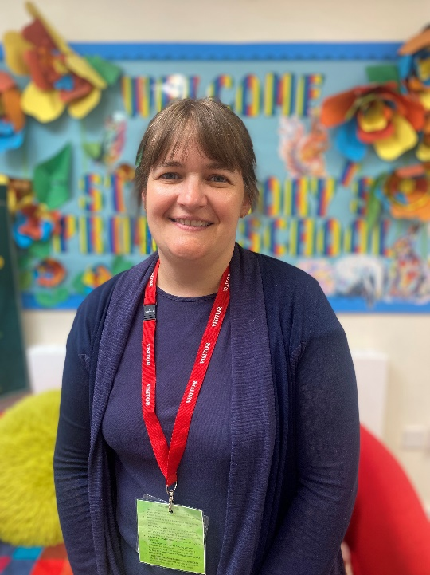

**KS1 MINI OLYMPICS – Thurs 4th July**

A joint event between us, St Mary’s Marnhull & Stower Provost. . This takes place in our school this year but unfortunately, parents are not able to stay for this event.

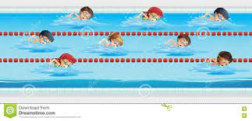**& SWIMMING GALA – Fri 5th July from 11.00am**

Everyone is welcome to attend our Sports and swimming gala events.

Sports Day will be in the morning from 11am, followed by whole school picnic on the field and swimming gala at 1.20pm, starting with our Hedgehogs class giving a little display of what they have been getting up to, before the year 2-6 races are held.

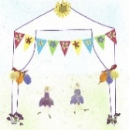**MARNHULL FLOWER SHOW – Saturday 6th July**

We have been asked to enter some children’s categories in this year’s Show. The Schedule of Classes was sent home on Friday 17th May. Please do go along to see how their entries fair.

**SCHOOL REPORTS - Weds 10th July**

Will be sent home, these will include Y6 SATs results and assessment data.

If you would like to discuss your child’s report with their teacher, please contact them via the class email to arrange a time on **Tues 16th July.**

**TUCK SHOP CAKES (EVERY OTHER FRIDAY) - Hedgehogs 12th July**

All profits from now on will go to fund the Guinea Pigs’ food and bedding; the children have a lot of fun looking after the school pets, so please support us with this venture. Looking ahead to the summer holiday, if you would like to look after the guinea pigs for the 6 weeks, please ask your child to write a persuasive letter to me saying why they think they would be the best person for the job!



**WHOLE SCHOOL PLAY – Weds 17th July Performances to Parents 1:45pm and 6pm**

(Dress rehearsal Monday 1.45pm), plus refreshments from 1:20pm and 5.30pm. As with the Carol Service, all children in the school are involved in both performances, with the older children (Foxes Class) playing the parts and the other children providing invaluable support with the singing. We hope you will be able to come and watch – please watch out for the PING coming out for reserving your seats and confirming your child’s attendance.

**SCHOOL DISCO – Thurs 18th July 5-7pm**

The Ice-pops sale and Sports Wear Day helped fund a professional DJ who has been booked for this free, fun event. There will be consent forms sent home and these have to be returned if you would like your child to attend. Thank you to the parents who are working hard to make this event happen to celebrate the end of term and the end of Primary school for the year 6 children!



**ALL WELCOME - Fri 19th July 8.50am**

The final celebration of achievements this term. Please drop off any certifcates, medals or trophies etc. beforehand

**SCHOOL LEAVERS’ SERVICE – Fri 19th July 2pm Led by Year 6**

This will take the place of our weekly church service where we say goodbye to our year 6 students.

All family members are welcome to attend

**Y6 EVENT – Fri 19th July 3.15pm**

Are invited to stay after school to enjoy a swim and a cream tea at school.

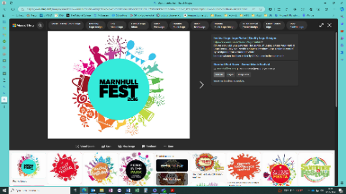**MARNHULL FEST GATE DUTY – Sat 20th July**

A Ping has been sent out (27/6/24). Please complete and return asap if you can help.

**SUMMER HOLIDAYS - Sat 20th July to Tues 3rd Sept**

Monday 22nd and Tuesday 23rd July are INSET Days – the school is closed as the teachers have carried out significant training throughout the rest of the year. Tuesday, 3rd September is also an INSET Day, so the children return on Wednesday 4th September

There are details listed on the school website for the local area [Things To Do Outside of School – St Gregs (stgregorymarnhull.dorset.sch.uk)](https://stgregorymarnhull.dorset.sch.uk/outsideschool/)

**CATERING – Stur Half Sun 4th Aug**

There’s an opportunity to raise some money for school by providing simple catering (drinks / cakes etc) at the annual race (held at Stur High). If you would like to run this then please let us know.

**VACCINE CLINIC – Weds 11th Sept**

A letter from the NHS will be sent to you on a Ping, for completion of the online consent form – the nurses will not be able to give the vaccine without this consent so please do look out for it.

With best wishes

James Stanford

**Please do use our school website for information.**

**If you have any questions / queries or need to book a time to see me for any other reason, do not hesitate to contact the school office or speak to me on the playground but please notify the office with general messages about your child.**

**Please note, emails and telephone calls will only be responded to within school hours.**



**READING VOLUNTEERS**

We would love to have more people to listen to readers. Please contact the office for a volunteer form, a DBS check will need to be carried out.



**HALL HIRE**

The school hall and field are available to hire for private occasions. Please contact the office for further details

**MUSIC LESSONS – From Y2 upwards**

Please contact the office or see the school webpage, if your child is interested in starting music lessons. [Music – St Gregs (stgregorymarnhull.dorset.sch.uk)](https://stgregorymarnhull.dorset.sch.uk/music/)

**MEDICINES IN SCHOOL / EMERGENCY ASTHMA INHALER – Consent Form Required**

It is vitally important that we have a completed form, if your child needs any medicine to be administered – otherwise we will be unable to do so. Please do not send children in with their own medicine to take – we need to be aware of any medicines in school. [Permission-to-Administer-Medication-Form.pdf (stgregorymarnhull.dorset.sch.uk)](https://stgregorymarnhull.dorset.sch.uk/wp-content/uploads/Permission-to-Administer-Medication-Form.pdf)

Plus, please keep your child off school if they have been vomiting and/or had diarrhoea for 48 hours after the last episode.

**EASY SCHOOL DONATIONS - Shop & Give Website**

Please sign up to the website and use the following code to find St Greg’s. Donations will be automatically paid to school each time you shop via their website.

School Code – 267421 [TheGivingMachine | Give For Free Every Time You Shop Online](https://shopandgive.thegivingmachine.co.uk/)

**SECOND-HAND UNIFORM**

Please do donate any that are out-grown and still in good condition and do check the rails in reception for any you might need. Please order any name tags for uniforms from [www.mynametags.com](http://www.mynametags.com)

They will donate a % of each sale to school when you use the School ID Code - 22362

**CAR PARKING**

The staff car park is for staff only, any visitor / parent parking is on the road but please do not park on the Bus Stop or Zigzags (this creates a problem for passing traffic as there is nowhere for them to pull in and is enforceable by law). The Crown pub also kindly allow parents to use their car park at drop off and pick up times. If for some reason you need to temporarily park closer to school – then please inform the school office and we will advise you where to park.

**EXTENDED SCHOOL / BREAKFAST & AFTER-SCHOOL CLUBS:**

You are able to book in for a half-term at a time. Please ensure that payments are kept up-to-date. You can deposit amounts on your School Ping wallet to spread the cost of this facility.

**ORDER DEADLINE – 2 weeks before**

Please sign up and choose options, if you would like to order school lunches [Dorset Meal Selector | Home](https://dorset.mealselector.co.uk/).

If you do not order in time, please bring in a lunchbox for the first 2 weeks. All children in years R,1,2 are entitled to free hot lunches.

**FREE SCHOOL MEALS**

If your child qualifies for free school meals, not only will they receive a healthy meal on every school day, they’ll also get, access to free holiday clubs, extra money for their school towards more teachers and activities. It’s easy to find out if you qualify - complete our confidential checker at dorsetcouncil.gov.uk/free-school-meals or telephone 01305 221090

**PUPIL PREMIUM**

If your child is in reception to year 2 and you receive qualifying benefits, you could get extra £££’s for your school!

Apply for the Pupil Premium at dorsetcouncil.gov.uk/pupil-premium

