[St Gregs – Where learning has no limits (stgregorymarnhull.dorset.sch.uk)](https://stgregorymarnhull.dorset.sch.uk/) 16th November 2023

Dear Parents / Carers,

This half term has already been incredibly busy, with the children becoming fully engaged in their new enquiries as engineers, scientists, historians and artists. The Curious-city based curriculum is adapted in each enquiry to reflect where our school is and the experiences our children have. Walks around Marnhull to look at the architecture, road structure amenities and natural features has given the children in Years 3 and 4 a much better understanding of the locality, while our younger children engaged in a productive litter-pick, raising their sense of community and how they can improve, and not spoil, the local area. Years 5 and 6 are preparing for their visit to Stonehenge where they will consider if people from Ancient Britain were, for their time, better engineers than the Victorians.

The staff have been very busy, too, making sure the curriculum is engaging for all the children, and providing a wide range of learning opportunities to hook their attention and ensure they are making good progress. We have also had a number of visitors to the school monitoring our progress, including governors and representatives from the Local Authority, Salisbury Diocese and Pickwick Academy Trust. All our visitors have been pleased to see the work we are doing and we have been grateful for their support and suggestions. As you will know, the school will be converting to an academy and joining the Pickwick Academy Trust on 1st February. We are very excited about this move and look forward to welcoming James Passmore, the CEO, to an assembly just before then, when he will be talking to the children and getting to know the school better.

****Y3&4 SWIMMING GALA - Clayesmore School**

**Thurs 19th Oct**

It was great for our school to take part in this event, our first competition of the school year. The children were very supportive of each other and had an amazing determination to win. A fantastic team effort out of 23 races they came 1st in 14, 2nd in 8 & 3rd in 1

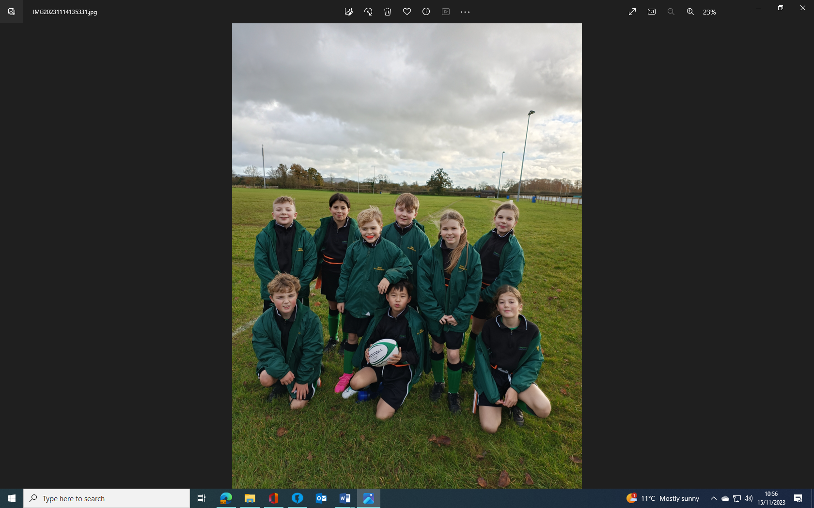

**Y4/5/6 TAG RUGBY – North Dorset Rugby Club Tues 14th Nov**

We were delighted to take part in the annual tournament this year, and despite the driving rain, the children maintained a great team spirit and became much more accurate in their tagging of the opposing teams and very quick to score tries. As always, the children performed incredibly well, winning 3 of their 5 matches, and this year they came 5th out of 10 teams, losing out only to the A teams from much larger schools.

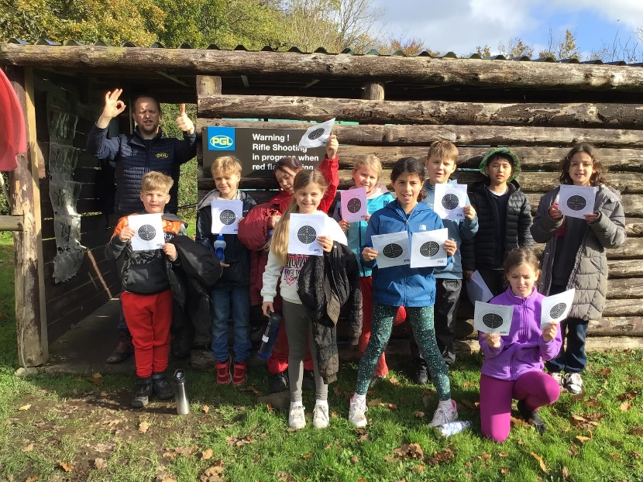

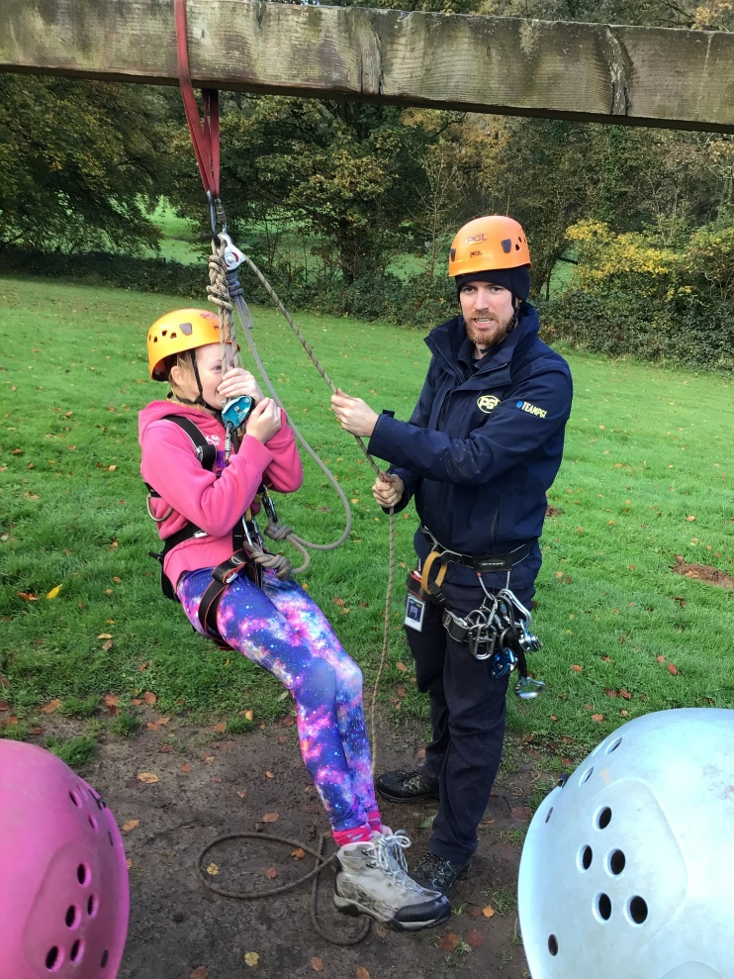

**Y5&6 RESIDENTIAL – Nov 23**

Children in Years 5 and 6 had a wonderful time at the PGL Beam House site near Bideford. Nearly 4 days of wall climbing, night-time wide-games, problem solving, zip wires, abseiling, rifle-shooting and archery, evening campfire and lots of singing kept the children entertained, busy and happy. They seemed to have a wonderful time and it was great to see them grow in confidence and, for many, be comfortable staying away from home for the first time. They all challenged themselves and each of them came away being proud of their achievements. We were very proud of them, too, and they were a super group to take away. Many thanks to Mrs Dunn for giving up so much of her time to come with us.

**NEWS**

As we join Pickwick, the Governing Body will become a Local Governance Board and, with much of the responsibility for budgeting and school premises, we will no longer need a Finance or Premises committee. The new LGB will still have a very important role in the running of the school and ensuring we provide the best possible experience for our children. Two parent Governors, Lucy Chalke and Dan Warren, and a new Foundation Governor, Caroline Collard, were recently appointed to the Governing Body – we look forward to working with them in this capacity.



**SCHOOL ANNIVERSARY – School Forum Thurs 23rd Nov 5.45pm (School Hall)**

2024 sees the 150th Anniversary of the founding of St Gregory’s School in Marnhull. This is a real cause for celebration and we would like to organise a series of events to mark this historic milestone. I am holding a meeting for all interested parties, (parents, governors, local community and staff) to discuss how we might organise these events and to make 2024 a special year for the school and the children.

Also at the meeting, I will be asking for support in organising a range of other events to enhance the children’s time at school. At a meeting of the new School Council today, the children were very keen to tell me about the discos, quizzes, film nights and Pyjama Days they enjoy, and it would be great if we could provide these, and other events for them. If you have any suggestions and would like to share them with me before or after the meeting, please don’t hesitate to get in touch.

**CHRISTMAS SHOEBOX APPEAL – with House of Opportunity** [Christmas Box Appeal for Schools - House of Opportunity](https://houseofopportunity.org/what-we-do/christmas-box-appeal/christmas-box-schools/)

Thank you for donations given we have managed to fill 16 boxes

**AFTER-SCHOOL CLUB**

Please let us know if you would like the club to be extended to 5pm. We would need a minimum of 4 children to attend and if you book this session and then do not use it the charge will still be made. Please inform the office if you would like to sign up. Also, if enough people are interested, we will open the After-School Club on Fridays until 4:15pm.

**WELLIES**

We haven’t been able to use the field much this half term because of the rain, but would like to give the children the opportunity to use the grounds to the full. Please send in a named pair of wellies to keep in school so that the children can play on the field at breaktimes.

**CLASS TRIPS**

We are still in the early stages of re-planning our whole curriculum, but the teachers have already made some plans for some more exciting visits throughout the year. Details of these will be sent home shortly.

**TERM DATES & EVENTS**

Are all on the Ping calendar and will be added to as more is confirmed.

**HARVEST FESTIVAL SERVICE –** Thank you for donations, these have been gratefully received by Carol from the Vale Pantry, when she visited Year 1 & 2 as part of their ‘How Can We Help?’ Enquiry. They are also running a Hamper Appeal and Reverse Advent Calendar:

**CHILDREN IN NEED – Fri 17th Nov**

We will be raising money for this annual event through a range of activities in school and as part of Anti-bullying Week, we will also be teaching the children skills to stay safe and happy. Children may wear onesies / Pudsey t- shirts / spotty clothes etc. Please give generously to this brilliant cause via: [St Gregory's CofE Primary School is fundraising for BBC Children in Need (justgiving.com)](https://www.justgiving.com/page/st-gregorys-cofe-primary-school-cin23)



**VACCINE CLINIC – Thurs 23rd Nov**

Please ensure the online consent has been completed.



**FOXES’ SAMBA PERFORMANCE – Tues 12th Dec 11.30am**

Parents are wamly invited to attend a short performance (20 minutes) to hear what the class have been learning. Our thanks go to Adam Colwell, the drum teacher for his time.

**CHRISTMAS GIFT SHOP – TBC**

I know that all our children love to choose presents for special people in their lives – this is their opportunity to do so at our gift shop. We will be asking for donations of gifts and a wonderful group of adults will help the children to wrap and decorate them. The children will need £3 per gift.

**NATIVITY PLAY & CAROLS - Tues 12th Dec 6pm (Dress Rehearsal 2pm)**

Children will need to be in school for 5.30pm.



**LUNCH, SANTA WALK & JUMPER DAY - Weds 13th Dec** [St Gregory's School Christmas Jumper Day is raising money for Save The Children!](https://christmas.savethechildren.org.uk/fundraising/CJD230001206) Children can wear Christmas jumpers to raise money for Save The Children. Please donate via the link.

If you would like to order the Christmas Lunch please visit <https://dorset.mealselector.co.uk/> or to check previously selected options and make changes, if required.

There are just two options on this day, the standard Main or the Vegetarian Option, there will be no Alternative option. If you have previously selected an Alternative option and do not amend your selection before the online cut-off, the meal will be automatically converted to the Vegetarian option.

The menu is now live on the website and the closing date for online orders is Midnight on Sunday 26th November.

Please email any requests for Allergen & Nutritional Information to BPDadmin@compass-group.co.uk

**LAST DAY OF TERM EVENTS – Fri 15th Dec**



**PRAISE ASSMEBLY (AM)** - Please let us know in advance if your child has anything they have achieved outside of school (clubs etc) and please send in their certificates / trophies etc for presentation at the assembly. All welcome

**PANTOMIME -** This year we are watching the performance of Puss In Boots from the school hall. This will be paid for by existing PTFA funds and will also be especially available to all families (until 30/12/23), with a link which will be sent out to you.

**BUFFET -** We will be having a Christmas buffet style lunch altogether on the last day of term and ask that each class’ parents provides some food. This will be sent out on a ping nearer to the time with specific lists per class.

Many more events are being planned for this term, the details of which will be shared with you as soon as they are finalised; I am sure you will encourage your children to take part in as much as they can!

With best wishes

James Stanford

**Please do use our school website for information.**

**If you have any questions / queries or need to book a time to see me for any other reason, do not hesitate to contact the school office or speak to me on the playground but please notify the office with general messages about your child.**

**Please note, emails and telephone calls will only be responded to within school hours.**

**READING VOLUNTEERS**

We would love to have more people to listen to readers. Please contact the office for a volunteer form, a DBS check will need to be carried out.



**HALL HIRE**

The school hall and field are available to hire for private occasions. Please contact the office for further details

**MUSIC LESSONS – From Y2 upwards**

Please contact the office or see the school webpage, if your child is interested in starting music lessons. [Music – St Gregs (stgregorymarnhull.dorset.sch.uk)](https://stgregorymarnhull.dorset.sch.uk/music/)

**MEDICINES IN SCHOOL – Consent Form Required**

It is vitally important that we have a completed form, if your child needs any medicine to be administered – otherwise we will be unable to do so. Please do not send children in with their own medicine to take – we need to be aware of any medicines in school. [Permission-to-Administer-Medication-Form.pdf (stgregorymarnhull.dorset.sch.uk)](https://stgregorymarnhull.dorset.sch.uk/wp-content/uploads/Permission-to-Administer-Medication-Form.pdf)

Plus, please keep your child off school if they have been vomiting and/or had diarrhoea for 48 hours after the last episode.

**EASY SCHOOL DONATIONS - Shop & Give Website**

Please sign up to the website and use the following code to find St Greg’s. Donations will be automatically paid to school each time you shop via their website.

School Code – 267421 [TheGivingMachine | Give For Free Every Time You Shop Online](https://shopandgive.thegivingmachine.co.uk/)

**SECOND-HAND UNIFORM**

Please do donate any that are out-grown and still in good condition and do check the rails in reception for any you might need. Please order any name tags for uniforms from [www.mynametags.com](http://www.mynametags.com)

They will donate a % of each sale to school when you use the School ID Code - 22362

**CAR PARKING**

The staff car park is for staff only, any visitor / parent parking is on the road but please do not park on the Bus Stop or Zigzags (this creates a problem for passing traffic as there is nowhere for them to pull in and is enforceable by law). The Crown pub also kindly allow parents to use their car park at drop off and pick up times. If for some reason you need to temporarily park closer to school – then please inform the school office and we will advise you where to park.

**EXTENDED SCHOOL / BREAKFAST & AFTER-SCHOOL CLUBS:**

You are able to book in for a half-term at a time. Please ensure that payments are kept up-to-date. You can deposit amounts on your School Ping wallet to spread the cost of this facility.

**ORDER DEADLINE – 2 weeks before**

Please sign up and choose options, if you would like to order school lunches [Dorset Meal Selector | Home](https://dorset.mealselector.co.uk/).

If you do not order in time, please bring in a lunchbox for the first 2 weeks. All children in years R,1,2 are entitled to free hot lunches.

**FREE SCHOOL MEALS**

If your child qualifies for free school meals, not only will they receive a healthy meal on every school day, they’ll also get, access to free holiday clubs, extra money for their school towards more teachers and activities. It’s easy to find out if you qualify - complete our confidential checker at dorsetcouncil.gov.uk/free-school-meals or telephone 01305 221090

**PUPIL PREMIUM**

If your child is in reception to year 2 and you receive qualifying benefits, you could get extra £££’s for your school!

Apply for the Pupil Premium at dorsetcouncil.gov.uk/pupil-premium



