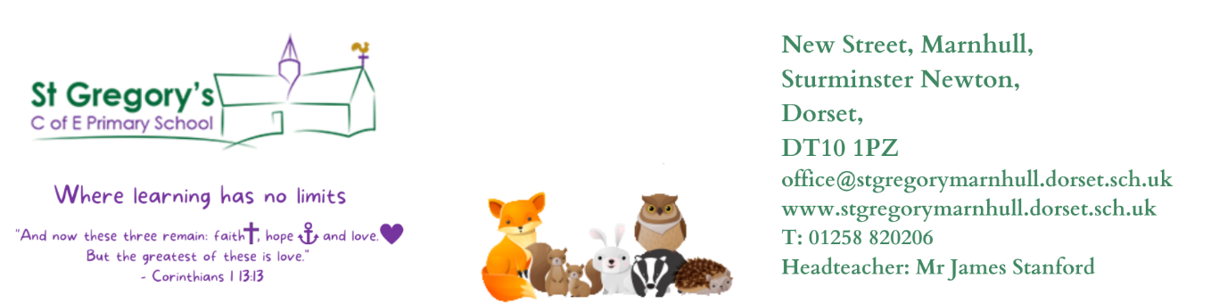

St Gregs – Where learning has no limits (stgregorymarnhull.dorset.sch.uk) 27th November 2023
Dear Parents / Carers,
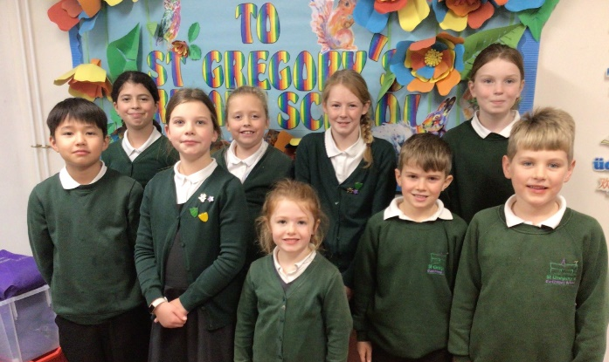
SCHOOL COUNCIL
Our newly elected School Councillors have been busy learning the roles and responsibilities of the council and have been putting their minds to work thinking of things we can do in school to make their time as good as it can be. They will also be running the competition for our 150th Celebration Logo and gathering the children’s ideas for events and activities we could organise during 2024.

Y3&4 NETBALL FESTIVAL – Gill High Thurs 23rd Nov
Children from Years 3 and 4 were invited to a special netball festival where they were taught the basic skills of the game and had fun in some competitive sessions. As always, we were very proud of their efforts and behaviour and they had a great time. For this festival we awarded a medal for Honesty, which went to Arlo who challenged himself admirably when playing with a range of children from other schools. Well done to all the children involved.

SCHOOL ANNIVERSARY – School Forum notes
We had a very productive meeting on Thursday evening, discussing a whole range of ideas to mark this historic event in the life of the school. Ideas from the planting of a spiritual garden to a party on the field, from a village quiz to a time capsule, from a display of photographs of former pupils to a Victorian lunch were all suggested. We will be putting together a programme of events for the coming months, with the hope that you will support us in making 2024 a very special year for St Gregory’s and its children. If you have any suggestions of events or activities you think would fit the theme, please email them into the office, or drop them into the suggestion box in Reception.

In order to give the year a kick start, the School Council are going to be asking each of the children to design a logo for all things 150^{th-}related. The winner will receive a special prize and will see their artwork on posters, tea-towels, letters heads and much more!

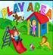
EARLY YEARS PLAY AREA
We are hoping the resurfacing of the outdoor area near Hedgehogs and Rabbits classrooms will get underway during the Christmas Holiday. If this is confirmed, we would be very grateful to anyone who is able to stay behind for a few minutes after the Praise Assembly on 15th December to help move the outdoor equipment into the hall or onto the playground to leave a completely clear area. We will also be looking for support in moving it all back again before the beginning of term... Please let us know if you will be available.

CHRISTMAS HAMPER – Donations & Raffle Tickets
We would be most grateful for lovely hamper items. Please drop these in to the office and buy raffle tickets, which will also be available at the tuck shop (£1 per ticket). Winners to be drawn at the Praise Assembly 15/12

CHRISTMAS CARDS – For Sale
We have had a generous donation of cards, by some parents. In the office lobby, all proceeds to the school.
Please do have a look. In the New Year we will also have some birthday cards for sale.

FABRIC / COSTUMES – For Nativity Characters
Please could everyone look for and bring in any spare, plain fabric which would be suitable for making costumes for the characters. We have a group of sewers (via the Church) willing to help make additional costumes. Please bring in by Friday 1st December. If you have any unused Nativity outfits please do donate these also.

CHRISTMAS CARDS
We know children love to bring in cards for their friends and teachers. There is a post box in the school hall, where children can put all their cards and these will then be sorted by our older pupils and delivered to classes. Please can children put on class names as well as pupil names.

PARENT/CARER QUESTIONNAIRE
Gathering your views is an essential part of the work we do at school. Knowing how you and your children feel about the school, what is the impact of the work we have done and then acting on your suggestions really helps us to make sure we are continually improving and making this school the best we can. We will send out a link to the questionnaire on a PING and we would be very grateful if you would complete it by Tuesday 5th December.

FOREST SCHOOL
We are restarting this fantastic lesson on Monday afternoons beginning 8th Jan.
Foxes / Hedgehogs / Badgers class weekly rotation. Pound is back too, for the classes not at forest school.
Please do get some waterproof trousers, coats, wellies and warm clothes prepared for this. If you have spares that no longer fit your child then we would be grateful if you could bring them to school for others to use.

FOXES’ SAMBA PERFORMANCE – Tues 12th Dec 11.30am
Parents are wamly invited to attend a short performance (20 minutes) to hear what the class have been learning. Our thanks go to Adam Colwell, the drum teacher for his time.

NATIVITY PLAY & CAROLS - Tues 12th Dec 6pm (Dress Rehearsal 2pm)
Children will need to be in school at 5.30pm (no earlier please).
Refreshments will be available in the Church between 5.30pm and 6pm.
All costumes for KS1 will be provided. Please could all KS2 wear their school uniforms.

CHRISTMAS CELEBRATION DAY – Weds 13th Dec
CHRISTMAS JUMPERS
Children can wear Christmas jumpers to raise money for Save The Children. Please donate via the link: St Gregory's School Christmas Jumper Day is raising money for Save The Children!

SANTA WALK 10am
Parents are welcome to join us for the Santa Walk.

WHOLE SCHOOL CHRISTMAS LUNCH
Staff will be joining the children on this special day.

CHRISTMAS GIFT SHOP – Thurs 14th Dec
We are delighted to let you know the Christmas Gift Shop will be open again this year! The children really enjoy selecting a present for someone special and then wrapping it themselves. Please make sure we have donations in by Wednesday, 13th December at the latest. The children will also need to bring in £3 per gift on Thursday, 14th.

LAST DAY OF TERM EVENTS – Fri 15th Dec
PRAISE ASSEMBLY 9am
Certificates to be given out and please let us know in advance if your child has anything they have achieved outside of school (clubs etc) and please send in their certificates / trophies etc for presentation at the assembly. All welcome. Raffle ticket winners for the Christmas Hampers will be drawn at the assembly.

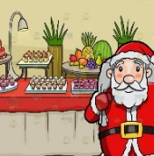
SHARED BUFFET LUNCH
We will be having a Christmas buffet style lunch altogether on the last day of term and ask that each class’ parents provides some food:
Hedgehogs: crisps / sausage rolls / pork pies / bread sticks / veg sticks / tomatoes
Badgers: Sandwiches – ham / cheese / cheese and pickle etc/ quiche / fruit
Foxes: cakes & biscuits
School will provide drink and decorations.

PANTOMIME
This year we are watching the performance of Puss In Boots from the school hall. This will be paid for by existing PTFA funds and will also be especially available to all families (until 30/12/23), with a link which will be sent out to you.

We will finish the term with our usual Friday Church service at 2.45pm, at which all parents are very welcome to join us.

All payments for cards / raffle tickets / gift shop / refreshments etc can be made by cash or card.

This is looking to be a wonderful end of the term for the children. I do hope you will be able to join us for the festivities.

With best wishes
James Stanford

Please do use our school website for information.
If you have any questions / queries or need to book a time to see me for any other reason, do not hesitate to contact the school office or speak to me on the playground but please notify the office with general messages about your child.
Please note, emails and telephone calls will only be responded to within school hours.

READING VOLUNTEERS
We would love to have more people to listen to readers. Please contact the office for a volunteer form, a DBS check will need to be carried out.

HALL HIRE
The school hall and field are available to hire for private occasions. Please contact the office for further details

MUSIC LESSONS – From Y2 upwards
Please contact the office or see the school webpage, if your child is interested in starting music lessons. Music – St Gregs (stgregorymarnhull.dorset.sch.uk)

MEDICINES IN SCHOOL – Consent Form Required
It is vitally important that we have a completed form, if your child needs any medicine to be administered – otherwise we will be unable to do so. Please do not send children in with their own medicine to take – we need to be aware of any medicines in school. Permission-to-Administer-Medication-Form.pdf (stgregorymarnhull.dorset.sch.uk)
Plus, please keep your child off school if they have been vomiting and/or had diarrhoea for 48 hours after the last episode.

EASY SCHOOL DONATIONS - Shop & Give Website
Please sign up to the website and use the following code to find St Greg’s. Donations will be automatically paid to school each time you shop via their website.
School Code – 267421 TheGivingMachine | Give For Free Every Time You Shop Online

SECOND-HAND UNIFORM
Please do donate any that are out-grown and still in good condition and do check the rails in reception for any you might need. Please order any name tags for uniforms from www.mynametags.com
They will donate a % of each sale to school when you use the School ID Code - 22362

CAR PARKING
The staff car park is for staff only, any visitor / parent parking is on the road but please do not park on the Bus Stop or Zigzags (this creates a problem for passing traffic as there is nowhere for them to pull in and is enforceable by law). The Crown pub also kindly allow parents to use their car park at drop off and pick up times. If for some reason you need to temporarily park closer to school – then please inform the school office and we will advise you where to park.

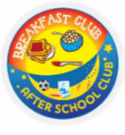
EXTENDED SCHOOL / BREAKFAST & AFTER-SCHOOL CLUBS:
You are able to book in for a half-term at a time. Please ensure that payments are kept up-to-date. You can deposit amounts on your School Ping wallet to spread the cost of this facility.

ORDER DEADLINE – 2 weeks before
Please sign up and choose options, if you would like to order school lunches Dorset Meal Selector | Home.
If you do not order in time, please bring in a lunchbox for the first 2 weeks. All children in years R,1,2 are entitled to free hot lunches.

FREE SCHOOL MEALS
If your child qualifies for free school meals, not only will they receive a healthy meal on every school day, they’ll also get, access to free holiday clubs, extra money for their school towards more teachers and activities. It’s easy to find out if you qualify - complete our confidential checker at dorsetcouncil.gov.uk/free-school-meals or telephone 01305 221090
PUPIL PREMIUM
If your child is in reception to year 2 and you receive qualifying benefits, you could get extra £££’s for your school!
Apply for the Pupil Premium at dorsetcouncil.gov.uk/pupil-premium

