St Gregs – Where learning has no limits (stgregorymarnhull.dorset.sch.uk) 7th June 2023
Dear Parents / Carers,
It is hard to believe we are already into our summer term. The last term for our Year 6 children and some members of staff. We have much planned – which is always a busy but enjoyable term – with the children being able to get outside more, enjoy the delights of our school pool and use the school field at every opportunity. We are incredibly fortunate to have the wonderful facilities we do.
As you are aware myself and Nick Chapman held a parent meeting before half term – to discuss all the changes coming to our school. Thank you to all those parents who attended and also those who were unable to attend but did e mail some questions. I felt it was a valuable meeting and have received very positive feedback for the information given. I am working on notes for the power point shown to explain what was said on the evening. This will be sent out later in the week, I hope any parents unable to attend will find this useful and help alleviate any concerns.
I would like to take this opportunity on behalf of the staff, children and myself to say a big THANK YOU to the PTFA members for their hard work and commitment to the school. The team raised important funds for us. It is with great sadness that they resigned.
We are now looking to gather together a new team to lead our PTFA alongside existing members. It is an opportunity to plan, organise, have fun and work with other parents to raise funds for our children. Please do not feel that you have to attend every event or be a major part – any help is gratefully received. With school funding as it is – the PTFA provide a vital part in giving our children resources / visits they may not have without this funding.
PTFA EMERGENCY GENERAL MEETING Tues 13th June 7pm (following Pickwick presentation) ALL parents welcome to come. We would love to see you there.

It saddens me to have to write this but following my recent information letter sent to parents, I have received an extremely unpleasant e mail from a parent – attacking me both personally and professionally. This is something that will not be tolerated in our setting; we always try to teach the children respect and how to behave when they are angry, lashing out at individuals anonymously is not appropriate and certainly gains no respect from anyone here. I have been advised to issue this warning – that St Gregory’s WILL NOT accept any abuse towards any of its’ staff or Governors. Nick Chapman our Chair of Governors showed total disbelief when he read the letter and dismay that one of our parents would actually be so nasty. Pickwick have been informed and moving forward they WILL NOT accept any communication of this kind.
This email is now in the hands of County and the Police.
Many, many parents are so supportive of myself and the team and for this I thank you. The kind, caring and respectful emails that have been received recently certainly do outweigh this one.

The pool is a great asset for our school and we are very lucky to have such committed parents who work hard behind the scenes for us, checking daily, hoovering, cleaning and making sure the chemicals are correct.
All teachers have completed their lifeguard training to enable us to take classes. As you know for a long time I have wanted to allow parents the use of our pool during weekends and the summer holidays – I am pleased to say that this can now happen. I have spoken with Dorset CC and finalised what MUST be in place.
I have arranged for a PARENT training session on WEDNESDAY 14th JUNE 12.30 – 3.00pm – a maximum of 15 parents can attend. A sign up form will be sent out. This will involve going in the pool at some point during the training, so please come prepared!!
For the pool to open outside of school hours x1 adult present MUST have this training and x1 adult MUST be a competent swimmer – BOTH MUST remain poolside constantly during the session.
Once the training has taken place we will be sending out a booking form and consent form, stating the rules and guidelines for hiring.

PE 4 IT – Thursday 22nd 2pm start – Friday 23rd June 2pm finish.
This is our fundraising event - 24 sports in 24 hours. Plus continuous running on our Daily mile track.
Please help support this event by coming and joining in with the sports, having some fun, bringing your families and enjoying raising valuable funds for school. We have chosen IT as we need to purchase some up to date laptops and I pads for everyday use.
Signing up sheets will be in the lobby from next Monday – but also please encourage friends and family to come along. There will be a variety of sports taking place throughout the time for example:
Bubble Football
Nerf wars
Archery
Rounders
Aqua swim
Tennis
Pound
Hockey
Kinball
Dodgeball
Plus, lots more. Please see sign-up sheet for further information.
Families are welcome to bring a picnic and watch proceedings on the field. Wet weather – activities will be in the school hall. The children are welcome to come after school and during the evening but must be supervised by an adult.
On the Friday they will also have the opportunity to try different sports eg wacky relay races, archery and bubble football, and will continue the challenge. All children have been given their sponsorship forms. Adults can be sponsored on our Just Giving Page https://www.justgiving.com/page/st-gregorys-school-pe4it?utm_term=vKQ3vnVgQ
It will be a long night but well worth it to be able to fund new resources for our children. Even if you can only come for an hour or two – anything helps.
Children can wear their PE kits to school Thursday & Friday
& SWIMMING GALA - Tues 4th July from 10.00am
Everyone welcome to attend our Sports and swimming gala events.
Sports Day will be in the morning from 10am, followed by whole school picnic on the field and swimming gala at 1.20pm.
All children will be taking part in the sports day and those who want to in the swimming gala.
Our Hedgehogs class will give a little display at 1.20pm of what they have been getting up to in the pool before the year 2-6 races being.
Marnhull Choir have kindly given us a generous donation for our garden area, from an event they held recently:
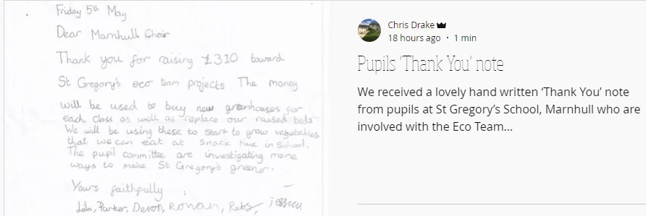

Diary dates (details to follow on Ping):
June
Tues 13th: Pickwick presentation to parents 2.15pm / 6pm
Tues 13th: PTFA EGM 7pm
Mon 19th: Theatre Production of ‘The Secret Garden’ inc Y6 Workshop
Thurs 22nd to Fri 23rd: PE 4 IT event + Parent Assembly at 1.30pm
Mon 26th: Year 3-4 PGL adventure day
Wed 28th: KS1 Mini Olympics TBC
Fri 30th: Whole school beach trip
July
Tues 4th: Whole school sports day and swimming gala
Wed 5th: Gillingham High School Induction Day. St Gregory’s move up morning – all children will go to their new classes
Thur 6th: Stur High School Induction Day
Fri 7th: Whole school spiritual day & Book Look at 3.15pm
Mon 10th to Wed 12th: Year 6 Residential to Carey Camp
Fri 14th: Non-uniform day End of year event on school field 3.15 pm
Mon 17th: Year 6 Dress rehearsal 1.45pm Year 6 Performance to parents 6pm
Wed 19th: Year 6 & Staff Leaver’s Service in the church – all welcome 1.30pm
Thur 20th: 12.45pm – Certificate Assembly – all parents invited. End of Term 1.30pm

Here’s to a wonderful summer term, the last for some staff and Year 6
We intend to make it a great one for ALL
Debbie Williams

