20th February 2023
Dear Parents / Carers,
Wow, what an amazing last week to the end of our half term, with our Mental Health and Sports week. The children had the opportunities to try many varied activities and explore keeping fit in different ways.
Feedback from the children has been so positive and lots of requests for another week like it. This is something I will definitely be looking into in my PE lead role. Please see below a snippet of some of the week. I will be organising a folder of photos to go on display in the lobby.

Children’s Mental Health Week
I started this week by introducing the theme of ‘Staying Connected’ and how we can do this through sport, friendships, community, across the world and the importance of speaking up when we don’t feel good about ourselves or what is going on in our lives. It is ok to talk and be honest about our feelings. Children accessed many resources and had very in-depth discussion about this theme at appropriate age levels.

Fri 3rd – Tae Kwon Do – My goodness did I see some very confident children in their Tae Kwon Do sessions. Loving the movements and being shown safely how to do this.
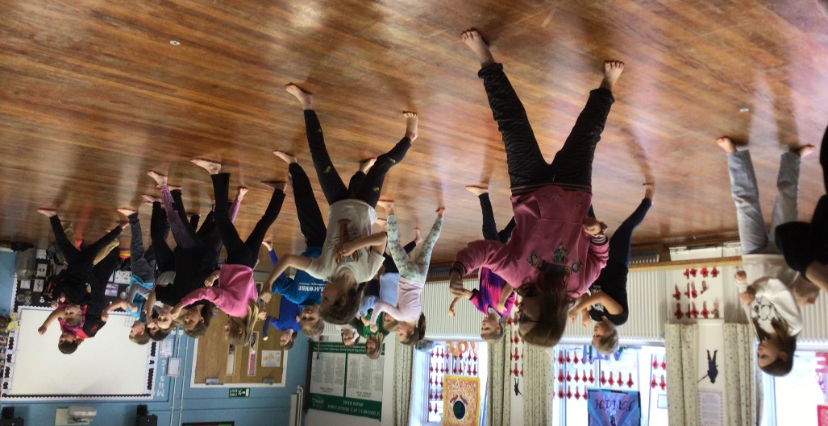

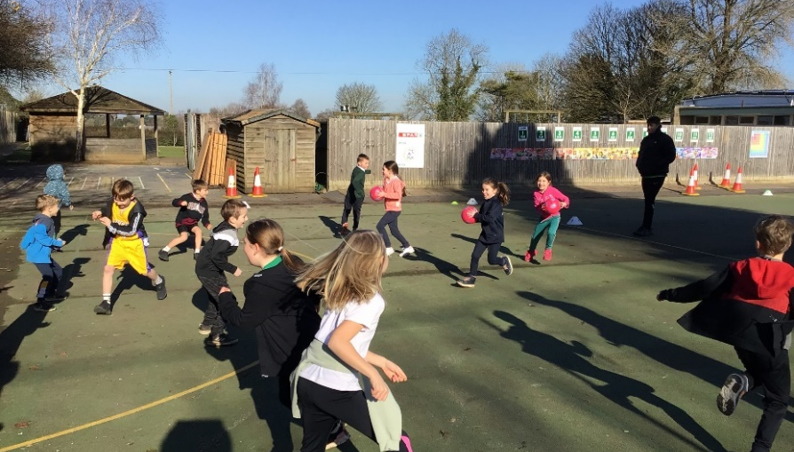

Mon 6th – Prime Sports - showed KS1 Handball, Team games and KS2 American football and Lacrosse. Fantastic activities to kick start our week
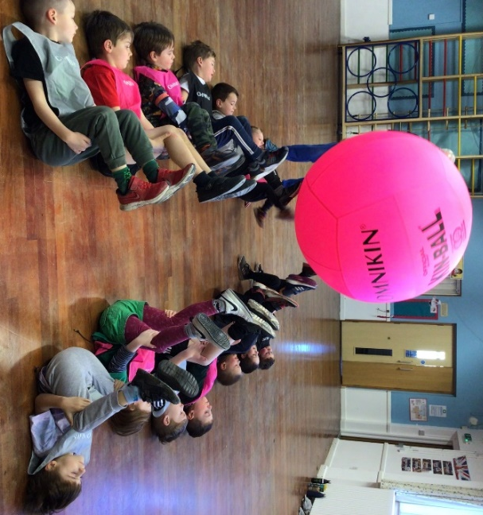

Tues 7th – Kinball day - What an exciting day this was – we loved this so much that we have now purchased a school set – so watch this space for a Kinball club in the future.

Weds 8th – Skipping – our daily pre-school skipping proved very popular – numbers kept on increasing through the week. It was lovely to see some parents attend with their children. The after-school workshop, was also a great success and again thank you parents for being such sports!!! I hope to offer more skipping early morning, especially as the weather improves – how lovely to have a playground skip first thing!!

Thurs 9th – Dance Club Performance at Mere Primary -
Our dance group took part in a North Dorset Dance Festival. They performed in front of 5 other school and pupils from Gillingham High School gave a critique of the performance – our girls received extremely positive feedback. The group have worked very hard since October, to produce such a slick, well-choreographed display.
I would like to say a huge thank you to Katy, Martha and Eve, who devised the dance and taught it
to the rest of the group – giving up much of their free-time to work on the routine.

& Forest School in our outdoor classroom and around the campfire

Pound in the hall - Everyone thoroughly enjoys their Pound classes with Hayley. She inspires, excites and creates a real vibe of fitness in our hall every week. So much so, that I have purchased our own set of 40 Pound sets to enable us to run our own classes in the future
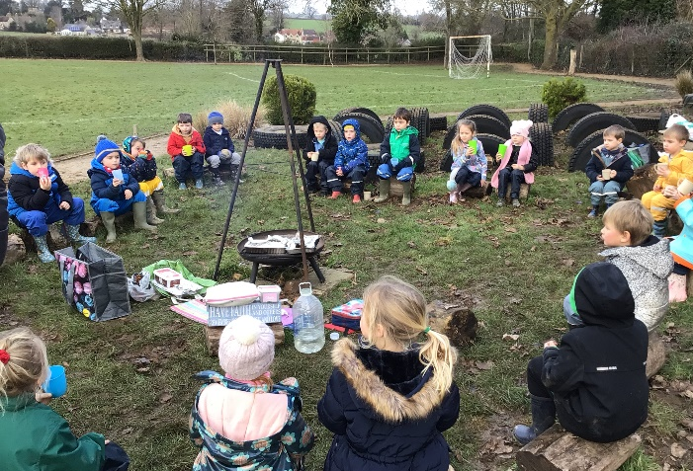

Safer Internet Day
We are very much living in a world of technology and part of our role is to give the children information to help them stay safe when using the internet. During the day the children looked at: use of the internet, what they should and shouldn’t be accessing, how to safely use programs and ways to ensure that their accounts are private and secure. Illustro Consultancy Ltd, a UK based company that provides international training and educational services to prevent, identify and deal with modern slavery and human trafficking are hosting a FREE ONLINE Human Trafficking and Online Safety workshop for parents on 4th of March on Eventbrite platform.
PTFA Valentine Disco
This was an amazing success – thank you to the committee who put together such an enjoyable, fun event for the children. Everything was considered: decorations, food, tattoos and even a selfie corner – which proved very popular – photos are on display in the hall, which the children have smiled at! Even the staff had a little boogie!!!
Foxes’ London Trip – Weds 22nd Feb
We had an amazing day out in London. In total there were 114 of us, touring the sights and experiencing the buzz of life in a city. Being able to meet other children from local settings and start to get to know them worked well. We had lunch in Green Park and then walked via Buckingham Palace, down the Mall, Whitehall to Downing Street and then across Westminster Bridge taking in the London eye, Houses of Parliament, eventually returning back over the Thames across Charing Cross Bridge and then the Mac Donald’s highlight!!!
This set us up for the theatre. Our Back To The Future experience was one, I don’t think the children will forget easily. Full of singing, dancing, wow moments and brilliant acting. The Adelphi theatre certainly made our visit very easy.
I would like to say the coaches were quieter on the way back but……..!!!!!
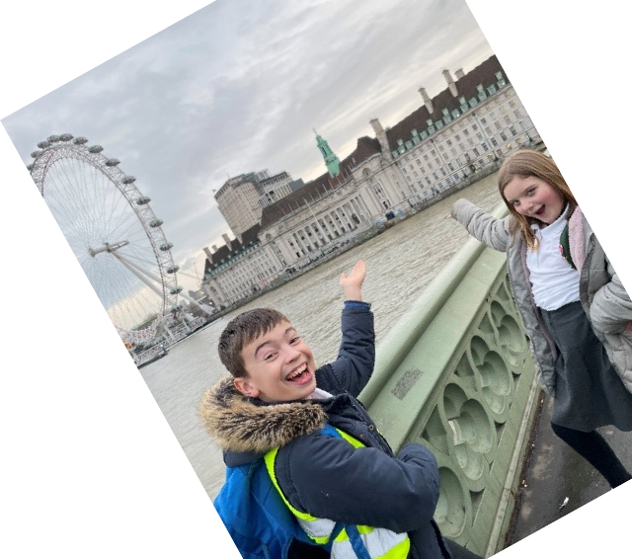
Thank you to parents who turned out in the middle of the night to welcome our return.
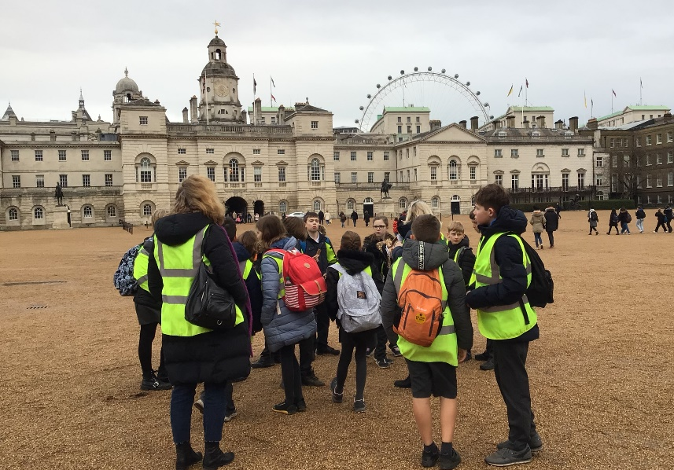

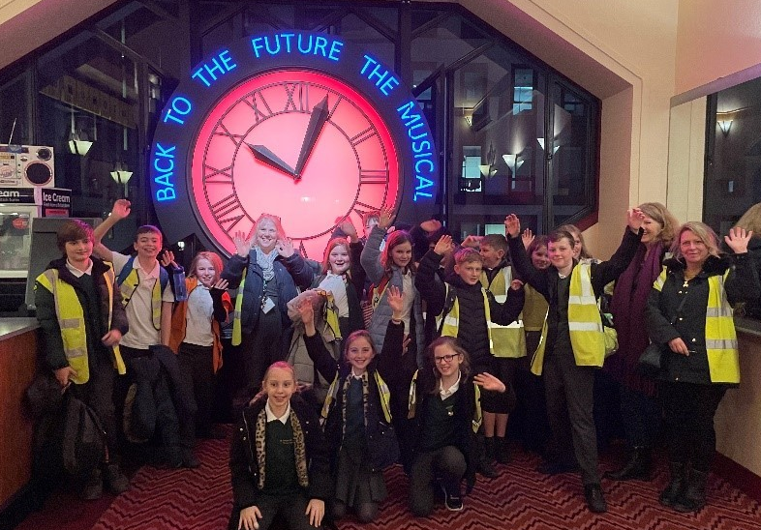

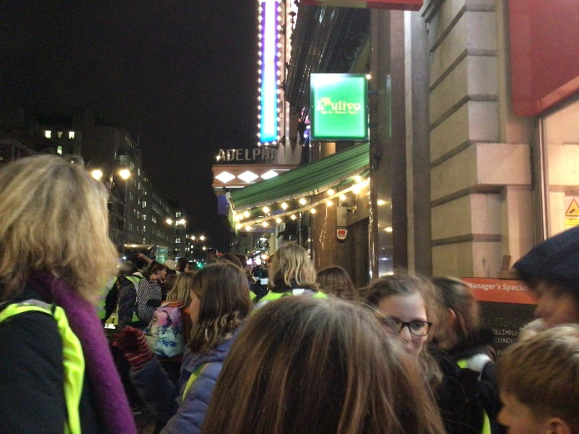

Owls Dikes’ Trip – Thurs 23rd Feb
Wonderful opportunity to learn about a professional café. A really enjoyable, local visit. Thank you Dikes!
Y6 SATs & Residential Meeting – Mon 27th Feb 3.15pm
This meeting will go through the SATS system and how prepare the children for this. Also, I will give a brief presentation regarding the Residential for Year 6 pupils, which will take place in July – a letter and ping will follow for this.

Teacher Industrial Action – Thurs 2nd, Weds 15th & Thurs 16th March
Please see the attached letter which gives further guidance about the arrangements for our school on these national teacher NEU strike days

Fri 3rd March
As mentioned on ping Update 20/2/23 – please come in non-school uniform, as a book character if possible but please do not go to expense or hassle!
In the morning the classes will be moving around school, visiting different literary stations and we kindly ask if parents have any magazines or comics that we could please borrow?
During the afternoon we will be doing a book swap – please could each child bring in a good quality book from home that is suitable for swapping?
This day will also be bring a donation for the PTFA Quiz and Curry Night raffle – please see attached poster. This is on Saturday 11th and is always a great parent / community event.

Sat 4th March – 10am
Jungle Hut are running this from the school hall. Please give donations for this (drop in at the School Office or Jungle Hut) and please come along to support this fundraiser – a tombola and refreshments will be available.

Parent View Meeting - Fri 10th Mar 2pm
All parents are very welcome to attend. If you are unable to but would like a matter raised then please speak with your class rep and they will ask on your behalf.

& Curry Sat 11th March – 7pm
At the Village Hall, run by the PTFA and hosted by Simon Hoare. Please email ptfastgregs@gmail.com for enquires.

Fri 17th March
The children can don the best home-made costume ever, go red from head to toe or simply dig out their brightest socks. I would love for the children and staff to wear something which makes them and others smile, in return for a donation to: St Gregory's School is fundraising for Comic Relief (justgiving.com)

Fri 17th March at 2.40pm – all welcome
Come and hear about all the wonderful things the children have experienced recently and be up for some Comic Relief challenges!!!

Y1&2 Gymnastics at Port Regis - Tues 28th March 10.30am – 12pm
As part of the School Games scheme, this is an opportunity for the younger years to get involved. We will be sharing a time slot with Whitesheet Primary. We will be asking parents to help transport, a ping will go out.

Whole School Spring Concert – Weds 29th March 6pm
Date now confirmed for our evening of musical entertainment. Performances will include the whole school choir as well as our violinists, drummers, guitarists and pianists plus additional instrumentalists. This will be held in the school hall.

Fri 31st March
On our last day of term, any form of headwear goes on this day to support this worthy cause: St Gregory's School is fundraising for Brain Tumour Research (justgiving.com)

Fri 31st March at 2.45pm
All parents are invited to see their children’s work

Fun Run – Sun 16th April 10.45am
For all children to enter either the ½ or 1 mile race, as part of the M12K annual school fundraiser. More details will follow

Owls Café – Date TBC
Parents of Owls are invited to join us to be customers of our pop-up café and enjoy the delicious smoothies that the class will make to order. We would love to have you join us!

School Questionnaire
This will be sent out on Sunday as an interactive Google form (link will be sent on Ping) – this really helps me get a picture of your thoughts and also to gather ideas, which all help to make our school a better place for your children

Tree Planting – Date TBC
We have been given 100 saplings to plant around school and we would love to have the help of some parents to plant these, one weekend day. David Loder of Marnhull Gardening club is kindly helping to develop our green spaces and he has been looking after the trees until they were ready to plant.

Cleaner Required
Please contact the office if you would like to apply, even on a temporary basis. From 3.30-5.15pm everyday (Fridays 2-5pm)

Reception & Year 6 Health Checks
As part of the National Child Measurement Programme all Reception and Year 6 children are checked by NHS School Health Nursery Nurses. Information and the consent form will be sent out on SchoolPing.
Reception is due this term (Y6 last term)

My job is made so much easier by the wonderful children we have at St Gregory’s; sharing their journey on a daily basis, seeing them blossom, learn and being safe and happy is my time to smile.
Thank you for entrusting my team and me with your precious ones.

Warmest wishes to you
Debbie Williams

