2nd December 2022

Dear Parents / Carers,

Wow, two weeks until the end of term and only 24 sleeps until the big day. The children are all very excited at starting our play rehearsals. We have so much planned for our final weeks, hopefull this newsletter will give you all the information needed.

Thank you so much to Pippa Jeffries for providing the Christmas tree outside Foxes and also Sarah Baker / Dan Warren for the one in the school hall.

This week the children have been doing their learning assessments, which means they can, next week them relax and enjoy all the activities until the end of term.

A huge St Gregory’s welcome to some other new children: Oscar Y1, Esmae R & Alfie Y1. We hope you will enjoy your time with us, make lots of new friends and create many memories.

Thank you to everyone who came to the Family Quiz night – organised and run by our amazing Pupil Parliament. They raised a fantastic amount of £170.39. I am sure they have many more events up their sleeve for next year.

**Christmas Shoebox Appeal – with FSCI** [Christmas Box Appeal - FSCI (fscinet.org)](https://www.fscinet.org/what-we-do/christmas-box-appeal/)

Thank you to all that kindly donated to these. We managed to make 29 boxes and they have been sent off to vulnerable children and families in Southeast Europe.

**Christmas Cards**

Christmas being such a wonderful time of year, I know children love to bring in cards for their friends and teachers. We now have a post box in the school hall, where children can put all their cards and these will then be sorted by our older pupils and delivered to classes. Please can children put on class names as well as pupil names.



**Phone Box Display – Burton Street**

By the KS2 Sketching Club. Please do go and have a look at the lovely Christmas display.

**The Vale Pantry – Donations by Thurs 15th Dec**

List below…

Please leave in the box in the Main Entrance



**Forest School**

We are hoping to start this fantastic lesson for each class again next half term. More info will follow about times but please do get some waterproof trousers, coats, wellies and warm clothes prepared for this.

**SEN Meetings**

Miss Edwards has been extremely busy in her new SENCO role this year. She hopes to meet with some parents this side of the holidays but as you can appreciate time is short, therefore she aims to contact other parents and will organise meetings to take place during the first three weeks of the new term.

**Inspection**

We are now awaiting the report which should come out before Christmas. We will send a link to this and offer a feedback session in the New Year to go through the detail of it.

**Tag Rugby Y5/6**

Amy, Isaac, Harry, Jacob, Katy, Laura, Rory, Tom, Zoe. They all did brilliantly, coming 4th out of 8 teams! Thank you to Prime Sports Coaching for their teaching, last half term.

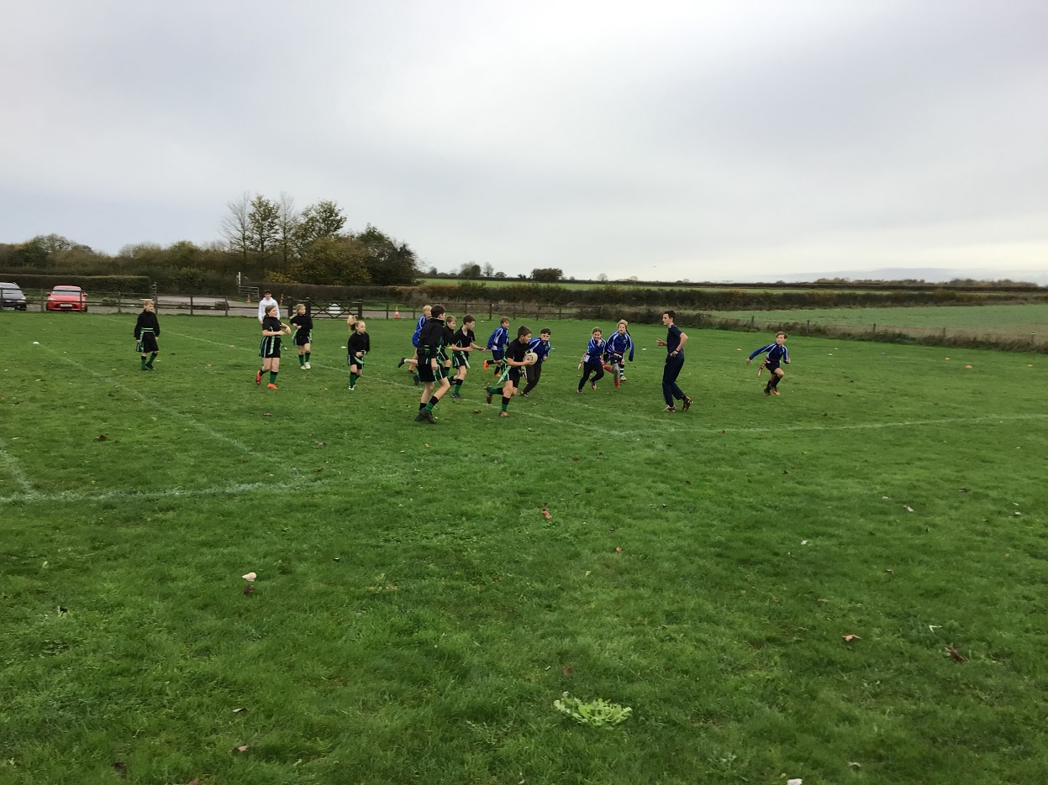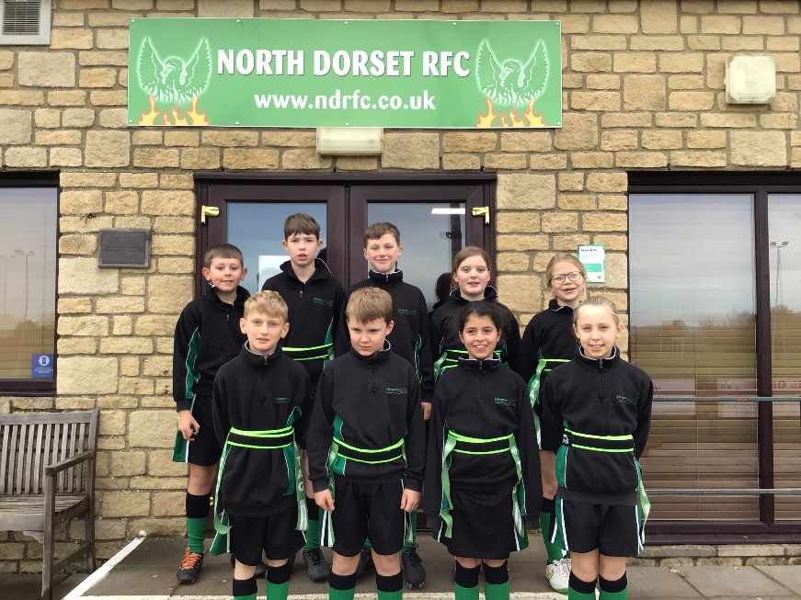

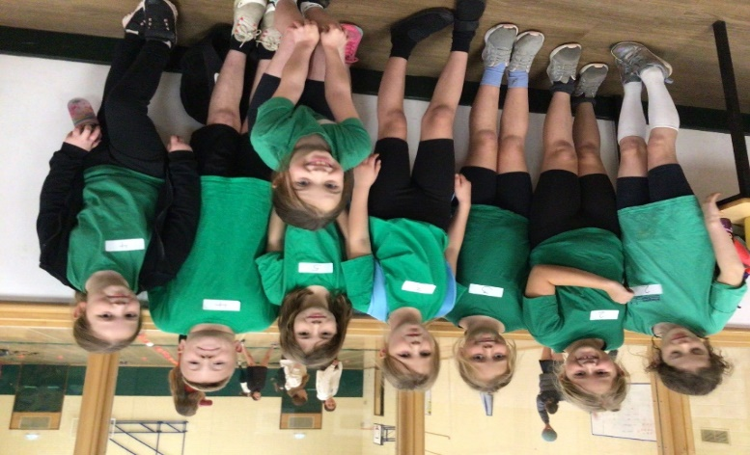

**Netball Festival Y3/4**

Leila, Izzy, Jessie, Karolina, Neri, Ripley, Alfie and Isobel all enjoyed learning some netball skills at Gillingham High school, working with the other local schools. They were split into pairs and took part in some circuits then played a game of Benchball:

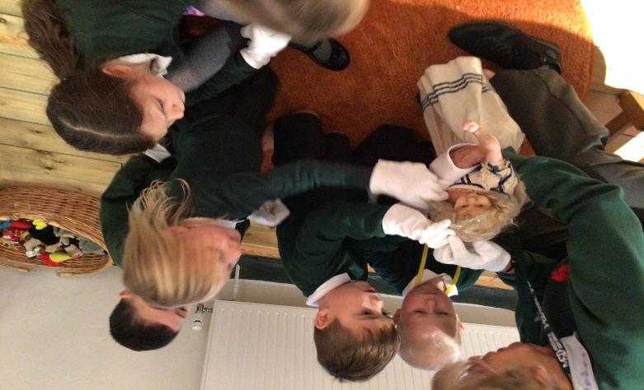

**Hedgehogs – Priest’s House Museum Trip**

We went to learn about toys and games from the past as part of our topic. Played old-fashioned games – Tiddlywinks, What’s The Time Mr Wolf and learnt some rhymes. Handled some very old toys +100 years! We had to wear special gloves to touch a china doll (in picture), bucking donkey money box and a pop up book.

We acted out the story of the Gingerbread Man in the old kitchen, next to the range – a really interesting day for all.

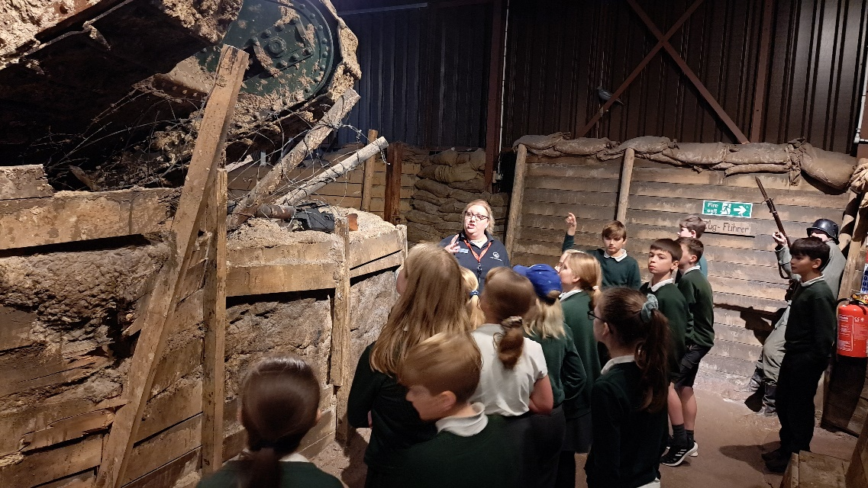

**Foxes – Bovington Tank Museum**

The trip was really enjoyed by the whole class and the museum staff were very impressed by all the pupils’ knowledge. We had Trench experience and a talk inside an original tank and learnt about the use of horses in WW1.

It was great to see the replica tank that was used in the War Horse film being moved into the museum. A really great experience for pupils and teachers!

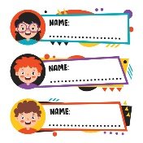

**Name Tags**

Please ensure that all uniform is labelled – you can order name tags from [www.mynametags.com](http://www.mynametags.com) They will donate a % of each sale to school when you use the **School ID Code - 22362**

It would help both staff and parents if we are easily able to reunite items with the correct child.



**Accountant Needed – PTFA Accounts**

Is there a qualified accountant that could audit the accounts for 21/22, please? As we were fortunate enough to raise over £25,000 we need to have the accounts checked, to comply with the Charity Commission.

**Welly Rack – Hedgehogs**

Would anyone be able to make an external rack for us to keep our wellies outside, please?

It would really help to reduce to mud coming in to the classroom.

**Payments**

You are able to add funds in advance to your wallet on School Ping, this enables you to have credit available to use against school trips, breakfast and after school clubs. Please read this guide for further details: <https://schoolping.co.uk/help/payments-help-for-parents?back-to> NOTE - Only one parent per child can have an active wallet, at any one time.

If you have any difficulties in paying for trips then please do come to the office

**Children In Need – Raised £136.50**

Thank you to everyone who donated. If you didn’t manage to donate at the time, the link is below:

[St Gregory's School is fundraising for BBC Children in Need (justgiving.com)](https://www.justgiving.com/fundraising/st-gregory-s-school4)



**Raffle Tickets – Draw at the Whole School Performance Tues 13th Dec**

There are some lovely hampers to be won to help raise more PTFA money. Tickets will be sent home shortly. Please do buy some, if you can.





**PTFA Parent Reps Meeting – Next Meeting Fri 13th Jan 9am**

It was such a pleasure to meet with parents at the meeting. It was a very open, relaxed and beneficial for myself and I hope parents. Lots of discussion took place surrounding the school and how tough getting staff has been, and continues to be so.

It was extremely humbling when parents rallied together and helped support the staff by cleaning – staff had been cleaning their own classes, cleaning toilets etc, as at that time we had no cleaners at all. My parents had been serving lunches and governors had been coming in to do lunch time duties to allow staff to have a break, when we had no lunchtime supervisors.

Parents raised questions about different aspects of school and through the open dialogue, I was able to put concerns to rest but also take forward some ideas presented to me.

Things such as knowing trips / costing in advance, would be helpful to parents and arranging a payment scheme, whereby amounts can be put in at any time – this is something we can look into.

Parents said they really enjoyed the opportunity to see their children’s books in classes and also come to Praise assembly.

I intend to arrange both of these, again next term.

Elly Ridout and I are working hard to ensure that the links between the school and parents are one of open communication and that any issues get dealt with effectively and timely. This though, does require parents to raise any issues with either myself, Elly or class reps.

These reps are:

Hedgehogs & Owls: Bethan Bolton, Rachel Bosley, Paul Stars, Callie Woodrow

Badgers: Zoe Bell, Michelle Tew

Foxes: Georgina Jones, Karen Maher

Thank you to all those who attended and I look forward to the next meeting. Please feel free to come along and share your ideas and pose any questions.

**Christmas Gift Shop – Mon 5th Dec**

I know that all our children love to choose presents for special people in their lives – this is their opportunity to do so at our PTFA gift shop. We will be asking for donations of gifts and a wonderful group of adults will help the children to wrap and decorate them. The children will need £2 per gift.

**Family Movie Night – Tues 6th Dec 5-7pm**

Come and have a relaxing time with your family at Christmas movie night. Bring your blankets, teddy bears and snuggle in your onesies and pyjamas. There will be one film, played in the school hall. Children £3.00 inc refreshments, Adults free – refreshments available to purchase by card and cash.

**Salisbury Cathedral – Weds 7th Dec 8.30am** **(Lunch Service has been cancelled)**

Whole school visit - we will experience a tour of this amazing place of worship and take part in a wreath making workshop. Cathedral staff will teach the children about the symbolism and what Advent means to Christians.

Please ensure your consent form and donation payment have been made in good time, for your child to be able to attend. All children are required to attend as this is an educational visit. If you do not give permission then you will need to keep your child at home, on this occasion.

**Afternoon Performance to Community and Parents - Mon 12th Dec 2pm -** refreshments will be available in the church

**Evening Performance - Tues 13th Dec 6pm** Children will need to be in school for **5.15pm.**

Refreshments will be available outside Foxes class under the tree from 5.15pm (weather permitting). Please make your way to the church by 5.45pm for a **6.00pm start.**

After the performance the children will return to their classes, where they can be collected.

We are not charging for entry and there is no upper limit on attending but there will be a donation box, anything contributed will go towards school purchasing costumes and items for drama productions.

**Costumes:** The children in Key stage 1 ( Rec’n, Yr1, Yr2) all have costumes provided by school.

Key stage 2: we ask that children wear all black, with some tinsel. Mary, Joseph , Angel Gabriel from Foxes – please can they wear something suitable for their roles. Thank you (Dress rehearsal Friday 9th December, in school)



**Cake Donations – Mon 12th Dec**

If any parents would like to donate some cakes for our Monday afternoon performance refreshments – that would be greatly appreciated. These can be brought to school the day of the play. Thank you.

**Pantomime – Weds 14th Dec (Lunch Service has been cancelled)**

A permission and payment ping will be sent out later.

Provision will be made in school if you do not want your child to attend or you can keep your child at home, if you would prefer.

**Santa Walk - Thurs 15th Dec 9am**

Our Santa walk is always hugely popular. Please join us when we will head off around the village, stopping at various places to serenade the community. Parents / Grandparents and dogs welcome.



**Christmas Jumper Day / Disco - Thurs 15th Dec (Lunch Service has been cancelled)**

Children can wear Christmas jumpers to raise money for Save The Children. [Our Christmas Jumper Day (savethechildren.org.uk)](https://christmas.savethechildren.org.uk/fundraising/st-gregorys-primary-school-christmas-jumper-d)

****We will be having a Christmas buffet style lunch altogether and ask that each class’ parents provides the food below:

**Hedgehogs: crisps / sausage rolls / pork pies / bread sticks**

**Owls: sandwiches – ham / cheese / cheese and pickle etc/ quiche**

**Badgers: tomatoes / cucumber / sliced carrot / fruit**

**Foxes: cakes & biscuits**

**Last Day of Term - Fri 16th**

I think we will all be exhausted by the time we get here, after all our lovely activities. Children can wear their own clothes on the last day. There will be a **Celebration assembly at 1.00pm and after this, at 1.30pm the children can go home.**

**School Choir (KS2) - Sat 17th 10.30am**

At The Hub / Repair Café (Village Hall 10am-12pm). We have been asked to provide some Christmas entertainment at the Hub. I would like to take at least 20 of our older pupils to sing some of our Hosanna Rock songs. There will be a school Ping asking for children to sign up to this.

They would need to arrive at the hub for 10.15am and be there for about 45 minutes.



**Sun 18th Church Service – Sun 18th**

All families are very welcome, some of the children will be doing readings.

Warmest wishes as always

Debbie Williams



