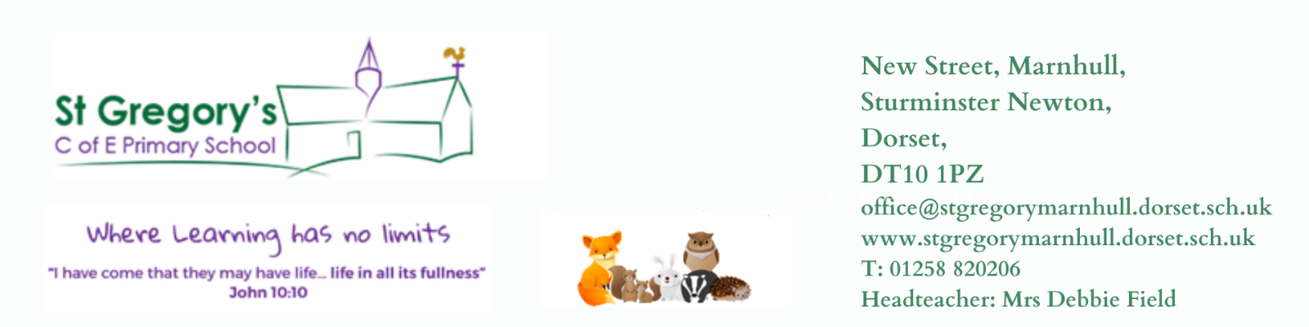

25th April 2022
Dear Parents / Carers

I hope you all have enjoyed family time with your children over Easter. What glorious weather we’ve had. I have been out with Daisy and Alfie (her best chocolate best friend!!), exploring bluebell woods - what a beautiful sight they are and of course looking after Cookie and Cream, who have been holidaying at home with me!!
Summer term – the term of sunshine, outside activities, sports, picnics, and at long last a whole turfed field which we can now use. The children will thoroughly love the space and being able to get back on the play equipment, I am sure. They have been incredibly tolerant and adaptable to the exceptionally small space of the past x2 terms.

Sadly, this newsletter brings the news that Mrs Barge will be leaving us at the end of the summer term. I am incredibly proud to announce that she has got her first headship, which will commence in September. She has been with St Gregory’s 5 years and has been such an exceptional member of the staff team, who will be greatly missed by all. She has been my deputy and stood by my side through some tough times and for that I give my heartfelt thanks. We will be giving her a St Gregory’s send off – well earnt.

Classes for 2022-23
Obviously with Mrs Barge leaving this has created a gap in our school team. Having spoken with all teachers and classroom assistants, the following classes for September will be:

EYFS / Year 1: Teacher Mrs Cooke-Pain TA Mrs Dunn

Year 2 / 3: Teachers Mrs Cheeseman / Mrs Chapman TAs Mrs Mogg + TBC

Year 4 / 5: Teacher Miss Edwards TAs Mrs Heasman / Mrs Mogg

Year 6: I will be making a new appointment for this class and will inform you of this asap.
TA Mrs Andrews
Mrs Dike will be working with either Badgers or Foxes – depending on Year 6 teacher.

I will possibly be appointing an additional TA depending on whether Mrs Irvine returns, she has been on long term leave.

The TAs in classes are not fixed and there maybe movement, depending on the different needs of the children in school.

If you have any questions regarding next year, please do not hesitate to make an appointment with individual staff or myself, via the school office. Happy to discuss any questions / concerns.

SENDCO from September – Miss Edwards will be taking over as the school SENDCO. I have thoroughly enjoyed the role this year but headship work and SEN commitment have at times clashed, I feel that Miss Edwards will do an exceptional job.

Parents’ evenings are this week – don’t forget to sign up using our school PING. These will be Face to face at long last.

Key Stage 2 SATS week is 9th May: please remember children may come in early for breakfast and to get settled before the tests. Early nights would be good this week!!!

Trick Box Coffee morning Friday 29th April 9.00am.
As I said in my previous newsletter, Mrs Dunn and I have now qualified to be facilitators for the Parent’s Trick Box programme. This is an exciting new venture for us and the school. We would love parents to take this opportunity to sign up to the programme. We are holding a coffee morning on Friday to talk through the programme and explain what it is all about, discuss possible options for the training eg dates and give you an opportunity to ask any questions you may have. We hope to see many of you there.
There will be more newsletters over the coming weeks giving information about visits, Yr6 residential, our Jubilee celebrations and summer activities

Best wishes to you all,

Debbie Field

