18th March 2022



Dear Parents / Carers,

My goodness, what a couple of weeks it has been. At times, we had less than 50% of our children in. Staff have been hit hard with Covid and some are still at home testing positive. We are over the worst now and are welcoming back increased numbers of children each day. Obviously, illness has caused disruption to the children’s learning, although online homework was set. All staff are working extremely hard to continue to cover any gaps.

We had hoped to hold Parent’s evenings this term but due to the Covid outbreak, we are postponing them and will be putting out details of Face-to-Face meetings to be done early next term.



**Support for Ukraine**

Thank you so much to all those of you who brought in items for Ukraine. My parents took everything to Gillingham and helped load onto a lorry last week. Unfortunately, clothing items were not taken, but these will now be delivered to Crazy Monsters in Blandford where they will be transporting another load next week.

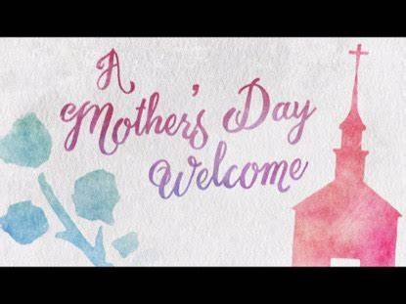**Mother’s Day Service - Wednesday 23rd March**

Next week we will be holding a whole school Mothers’ Day service in church. All classes will be presenting a little something. We would love some Mums and Dads to attend, if they can.

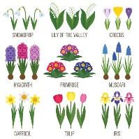 **Gardens & Signage:**

The Marnhull Gardening Club are very kindly helping to restore plants in the school grounds.

There are plans for a spiritual garden and we have wild cherry trees to plant.

There will also be new signage installed to help brighten up the front and the railings are to be painted green too…

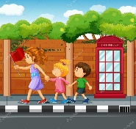

**Road Safety:**

To ensure everyone’s safety, when waiting at the school wall to drop off or collect, please give space for others to get by on the pavement so that no one need walk in the road.

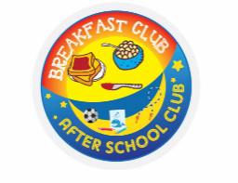**Extended School:**

We are happy to announce that we can offer an 8am drop off for children needing it, after Easter. There will be a new charging structure for this increase:

8am £2.75 (from Summer Term) & 8.10am onwards £2.50

We have also had to review the charges for breakfast and after school clubs; from September 2022 they will increase as follows:

Breakfast Club 8am £3.25 8.10am £3

After School £5 for the first child and £4 for the second

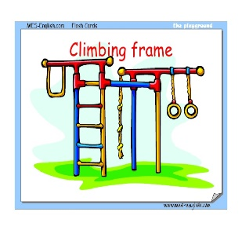

**PE Equipment:**

Thanks to the Government Sports Funding, we have a lovely new set of equipment in the hall for gymnastic PE lessons, new climbing frames, mats and bars.

**New Pupils:**

It is always lovely to welcome new pupils to St Gregory’s. This half term we have 3 new starters – Poppy (Y4), Isobel (Y2) and Ryan (Y1). We hope they enjoy being with us, make many friends and build wonderful memories here.

**Explore The Orchestra - Tuesday 17th May:**

KS2 will be visiting Poole Lighthouse Theatre to see a special schools’ concert performed by the Bournemouth Symphony Orchestra. A Ping will be sent out for this.

The concert features an exciting selection of repertoire that will take the audience on a journey through the magical night. We will be exploring the night sky, the marvellous moon and stars, and some magical film music.



**Saturday 19th March – in support of the crisis in the Ukraine**

Organised by the PTFA, please come and support another great event organised by the PTFA – see poster attached



**Ground-source Heat-pump – Wellies still needed!**

Work has now been completed and the area will be turfed and ready to use after the Easter holidays.

It is all part of becoming a greener school….



**Recycling:**

Since our whole-school topic in the Autumn term about Reduce, Reuse, Recycle we have been making changes to help the environment:

Composting fruit / veg leftovers, shredded paper and Guinea Pig bedding

Food waste goes to the food bin

Milk cartons have been replaced by cups and good old-fashioned glass bottles

We separate out soft plastics for recycling (crisp / chocolate packets, wrap and bags)

Foil lunch trays are washed and recycled

All other paper / cardboard / tetra-paks / plastic / cans go in to our large recycling bin

The Hub collects our old pens for recycling

There is a collection box for used printer cartridges in the lobby

We have signed up and are now waiting for collection boxes to recycle old plastic toys and tech. This will give us money back for books: [The Pod | Recycle to Read 2021-22 (jointhepod.org)](https://jointhepod.org/campaigns/recycle-to-read-2021)

**Friday 18th March:**

Please do support the charity by donating:

[St Gregory's School is fundraising for Comic Relief (justgiving.com)](https://www.justgiving.com/fundraising/st-gregory-s-school2)

**Reading Helpers:**

If you would like to volunteer, please complete the attached form. We do have Gnasher the Reading Dog in twice a week but we would love for more listeners as it is so helpful for the children.



**Music Lessons:**

Dorset Music Service are no longer providing a booking service for music lessons. After Easter all music teachers will be invoicing you directly. Lesson times will continue to be arranged through school

**Clothes Recycling – At Jungle Hut w/c 21st March**

Please help support their fundraising effort by bringing in unwanted textiles and clothing for a Bag 2 School collection on Weds 23rd March. All the info on what they will and won’t accept is on their website:

[Bag 2 School](https://bag2school.com/what-we-collect)



**Easter Holiday Activities**

Please see the link [Things To Do Outside of School – St Gregs (stgregorymarnhull.dorset.sch.uk)](https://stgregorymarnhull.dorset.sch.uk/outsideschool/) for activities to book. The Sherborne Activate camp is offering a 10% discount code for all bookings: STGREGORYS10

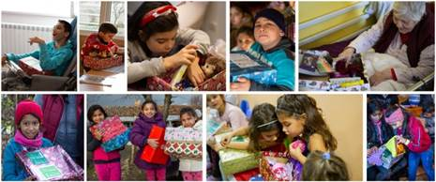

**Message from the Christmas Shoebox Appeal 2021:**

**Thank you** to the pupils, families and staff of St Gregory's C of E Primary for your wonderful donation of shoeboxes to our 2021 Christmas Box Appeal! Our amazing supporters donated a total of 7,934 boxes to the appeal, and spread a lot of joy throughout Bulgaria, where the presents were distributed in December.

Here is a thank you certificate (in the lobby), and please do pass on our thanks to the children and parents who took part.

 We could see what the Christmas boxes meant to the people who received them. The fact that a stranger cared enough to send a present, and the way in which the Christmas boxes were prepared never failed to make an impact. You can see Christmas boxes being distributed on our [YouTube channel](https://www.youtube.com/channel/UC3rDP8VPUwxUZTysfdLP60A/featured).

**Beyond Christmas -** FSCI’s projects tackle big social issues all year round, such as human-trafficking, extreme poverty and the marginalisation of vulnerable people.  You can find out more about our projects [here](https://www.fscinet.org/what-we-do/).



Warmest as always wishes

Debbie Field

