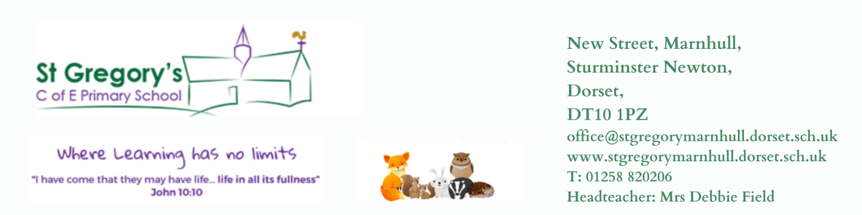
1st November 2021

Dear Parents / Carers
I hope you all had a wonderful half term with your children and despite the wintry weather you managed to get out and about. The clocks have now changed and scarily we are already starting to think about Christmas. This is always such a busy but lovely term in school, with many exciting events to look forward to.

My thanks to those who attended our Stay & Learn morning before half term. I hope it gave you a lovely insight into life at St Gregs. We will look to do something similar next term.

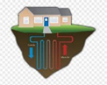
Work on our Ground source heat pump has commenced, fencing has gone up and the site is secured. The children will be given opportunities to hear about the work and have any of their questions answered by the site manager. I am sure there will be many little faces at the fence interested in the large drillers and machinery over the next few weeks.
Public Health Dorset has sent out some guidance to schools for the next couple of weeks regarding additional precautions. Due to Covid cases in the South West having steeply increased, making us one of the highest areas in the country, there has been a consensus statement issued and all schools in Dorset are now in the amber or red category. We will temporarily be re-introducing key stage bubbles, no whole school inside gatherings, staff masking in communal spaces, limiting visitors unless essential, requiring anyone who does enter school to be masked up, ensuring adequate ventilation and good hygiene procedures continue to be in place. Public health will be reviewing the impact of this across the county after the timescale and will inform us if it needs to be continued.

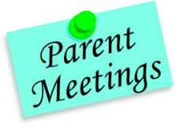
Due to us putting in tighter restrictions again, we will be postponing our Face to Face parents’ evenings. We will reschedule for a later date or do them online, as previously. I am sure though you will agree, face to face meetings are much better and we would prefer this to happen. We will keep you informed regarding this.

Please can I remind parents / carers to send children in with a suitable warm / waterproof coat – we like the children to get outside as much as possible at playtimes / lunchtimes and recently it has been quite cold outside.

Consent form and payment requests will be going out for the whole school pantomime trip on Monday 13th December.

St Gregory’s Church is running a 30 minute informal Family Tea Service at 4pm on the first Sunday of the month. It is designed for families with children of Primary school age- whether or not they come to church at other times. There is a Bible story, a song, a short interactive talk and prayer and sometimes craft- all in 30 minutes!- plus tea and homemade cake afterwards. Families with children are always welcome!

Reading Volunteers:
Please contact the office for DBS checks and then we will contact you to arrange dates for reading with the children.

Going Home:
As we need to be sure that you have given consent for your child to be collected by someone other than their usual carers, please inform the office of any additional names of people that you would like to pick up your child at the end of the school day.

Reception & Year 6 Health Checks:
As part of the National Child Measurement Programme all Reception and Year 6 children are checked by NHS School Health Nursery Nurses. Information and the consent form will be sent out on SchoolPing for Year 6 this week. Reception letter will follow soon.
From Sturminster Newton High School for Year 6 Students:
Please find below a link to a video we have put together to show what our students have been up to this Half Term https://www.facebook.com/571299693043661/videos/4428956943838173
Safety Update from Dorset & Wiltshire Fire Service:
With Bonfire night soon upon us, it is important that your child understands how they can help keep themselves safe. Dorset & Wiltshire Fire and Rescue Service have produced this sway Halloween and Bonfire Night (office.com) (which can be opened on any device with internet connection) which you can use with your child to aid discussion in how to stay safe near fireworks, bonfires and other flame sources. There is also the chance to enter a free prize draw for a VIP trip to a DWFRS fire station! (Ts& Cs apply – see sway for details)
We encourage you to talk to your child about safety at this time of year and use this resource to aid you and remind you of the main safety advice. Halloween and Bonfire Night (office.com) Thank you, good luck if your child enters the prize draw and have a happy and safe half term break. Dorset & Wiltshire Fire and Rescue Service.
A part of the council’s aim of understanding the effect of Covid-19 on travel habits/behaviours with regard to people’s journeys to school and colleges, Kevin Humphreys has produced a quick survey for parents, carers and students (who travel independently) regarding their journey to school and college.
This this online survey has been launched as an opportunity for parents, carers and students (who travel independently) in Dorset to share their views and let Dorset Council know about any issues they may be experiencing. Your responses will help the council’s transport team to build a better picture of school travel across the county and will help them to look at what changes might be possible to improve transport, congestion and the environment in your area.
To start the survey click here The survey closes on Friday 12th November 2021.

Poppy Appeal - We have been given items for sale to raise money for this cause. Please send your child in with funds next week, if you would like to support.
Flu Clinics - Will be held next Thursday at school. A letter from the NHS will be sent to you on SchoolPing. Please complete the online consent form.

On a personal note, I was taken into hospital before half term and spent most of the week there. I am pleased to say I am home now but unfortunately am awaiting further investigations / appointments regarding my spine, to decipher exactly what is happening. I really wanted to return to school following half term but sadly my health is not allowing for this. It’s a case of my mind and heart want to but my body and head say NO!!!!! I will try to attend any key events, if possible. Mrs Barge / Mrs Shea and I will be in regular contact and I will be working from home at points during the day. Please do not hesitate to get in touch with either of them if you have any concerns or queries. I know that the school is in extremely capable hands and the whole team will support one another.
I am missing everyone and hope it won’t be long before I am fully fit and marching up and down the corridors!!

Warmest wishes

Debbie Field

