Maths in Hedgehog Class

It is never too early to begin maths with children. Even the youngest will use maths in one way or another in everyday life

EYFS (Early Years Foundation Stage) Maths

In the early years we focus on numbers, EYFS will have been working on 1-5 in their first half term, specifically; what they look like, learning how to count amounts and the different representations of those numbers, for instance; 1 and one.

Children in EYFS will also begin the foundations of addition and subtraction, looking at how they can make up the number 4. e.g. 1 and 3 and 2 and 2.
Counting features every day in Hedgehog class, we practice counting both forwards and backwards to 20, we focus on becoming familiar with the pattern of numbers and start looking at 1 more or 1 less.
Shapes will also feature early in school life.
Year 1 Maths

The children have started year 1 securing their knowledge of Addition and Subtraction facts and strategies. The next small steps of addition they shall be covering in the next few weeks.
- Part – Whole model
- Addition symbol
- Fact families
- Find number bonds for numbers within 10
- Systematic methods for number bonds within 10
- Number bonds to 10
- Compare number bonds
- Addition – adding altogether
- Addition- adding more

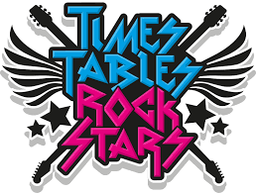
Times Table Rock Stars

Year 1 children have their own log in detail for times table rock stars, we use this throughout their time at St Greg’s – all the way up to year 6! Individual log on details to the site can be found in each child’s reading record. Click on the logo to go to the site.

Other great websites to help with maths can be found here:
https://www.topmarks.co.uk/

http://www.topmarks.co.uk/maths-games/3-5-years/counting

http://www.crickweb.co.uk/Early-Years.html

http://www.ictgames.com/resources.html

