***St Gregory’s SEN in a nutshell – Summer 2021***

**Priorities**

Closing of the gap for our SEND children

Ensuring staff are continually kept up to date with SEND CPD

Systems / structures in place as our SEN cycle to be further embedded

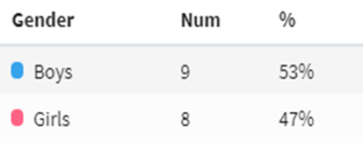

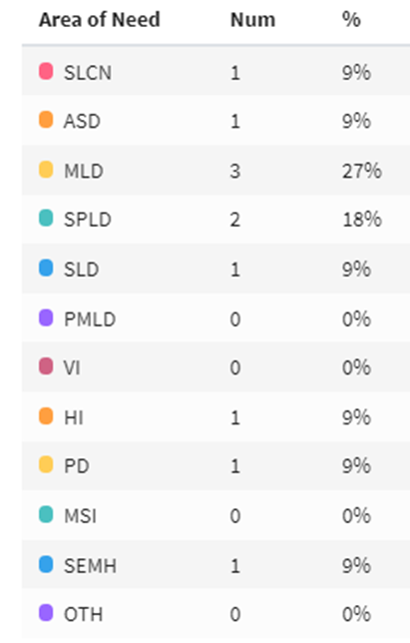 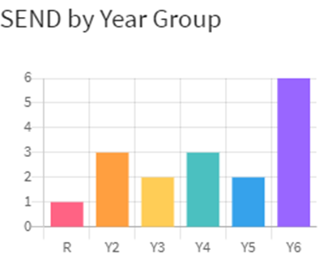

**Barriers to learning:**

Parental engagement with supporting children at home

Time constraints for Tas (funding)

Behaviour

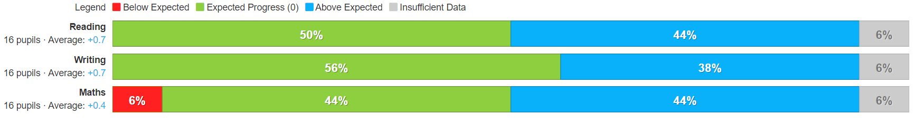

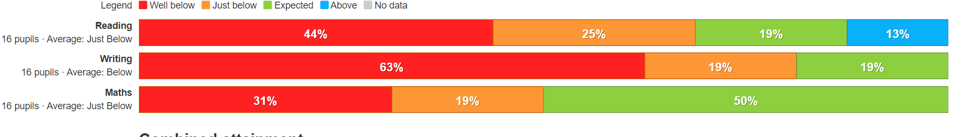

**Provision provided through:**

High quality first teaching

Ensuring staff deliver high quality interventions / catch up – close the gap

Precision Teaching

Reading support

Maths intervention

Nessy

TT Rockstars

Learn to move

Effective Marking & Feedback

WEB sessions for social, emotional, behaviour needs

Develop learning of ‘whole child’

Access to curriculum