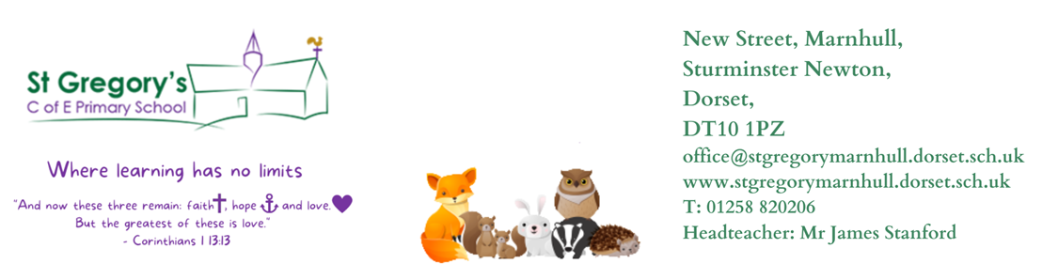

Friday 3rd November 2023

Dear Parents and Carers

Firstly thank you for those of you who were able to join us for parent consultations before half term, if for whatever reason you were unable to attend please see one of us and we can rearrange an appointment at a convenient time. Everyone in the class has well and truly settled in and our new Reception children are following the routines and making friendships, both within class and across the school, which is so lovely to see.

Daily Routines
The new routine of coming into school at the start of the day is working well and this is contributing towards the childrens independence and skill of being resilient. Please can your child have their book bag in school everyday along with their reading records and reading books.
PE: Mondays and Fridays: kits can be kept in school all week, to help with ease of changing please could the girls wear trousers and socks on these days if they have them.
Home learning: green home learning books need to be in school on a Thursday so that we can put new sounds for Reception and spellings for Year 1 into them ready for going home on a Friday. Year 1 have their spelling quiz on a Friday so please try to learn them for this day.
Library books: These need to come back on a Thursday ready for changing on a Friday.
Story sacks: These are books for you to read to your child, each sack has a book and a teddy for your child to read to and cuddle. These will be sent home on a Friday fortnightly. Please return both the book and teddy on the following Monday.

Curious City Enquiry

This half term our new enqury question is ‘How Can We Help?’ exploring how we can help others through acts of kindness without expecting anything in return. It uses freeze frame storytelling as a means of focusing the children in ways to articulate acts of kindness. Our act of kindness is going to focus on our shoebox appeal for the House of Opportunity. The children will be exploring the use of drawing, modelling and photos along experimenting with sound effects to convey meaning. The lead state within this enquiry is being an Artist along with the supporting state of being a Musician. The children’s final challenge at the end of their enquiry is to create a story board depicting an act of kindness and perform using sound effects. We will be using an empty shoebox to create a backdrop if anyone has any spare please send them in with your child. The Reception children will be following the same theme of ‘Acts of Kindness’ exploring what an act of kindness is and showing these both at home and in school. As part of this they be creating a kindness tree. As well as covering seasonal topics such as Autumn and learning through play with continuous provision.
The following table shows our learning across other areas of the currciculum

 | Reception | Year 1
As Authors we will be looking at… | Texts: Kind by Alison Green  The Jolly Postman  Poetry
 | Letter sounds  Letter formation  Oral sentence building | Sentence structure  Suffixes  lists
As Mathematicians, we follow the White Rose Maths Scheme, looking at… | It’s Me 1, 2, 3  Circles and Triangles  1, 2, 3, 4, 5  Shapes with 4 sides | Addition and Subtraction to 10  Geometry: Shape
As Philosophers we follow PSHE Jigsaw and Discovery RE, looking at… | Celebrating Differences
 | What gifts might Christians in my town have given Jesus if he had been born here instead of in Bethlehem?
As Musicians, we follow Charanga Music, looking at… | Singing and performing using tuned and percussion instruments
As Athletes, we follow Get set 4 PE Scheme, looking at… | Outside: Balls skills  Inside: Gymnastics
As Computing Scientists we follow Teach computing , looking at… | Internet safety  How can I paint using a computer?

Reading and book bags
Reading is an invaluable skill that your child will use across all areas of the curriculum and throughout their lifetime. Discussing and sharing books with your child is an important element of becoming an independent reader. When sharing books with your child discuss the events, plot and feelings of the characters and where possible relate to their own experiences.
All of the children in Year 1 already have a reading book if possible please aim to read at least 4 times a week to help with fluency and word recognition. At the back of their reading record is a tricky word bookmark or sounds for Reception, please practise these regularly. When you have read with or to your child please record in the reading record.

Home Learning
All children in Reception will be learning a number of new sounds each week. In their green home learning book they will have weekly sheets of the sounds we have covered for you to complete with them. In Year 1 children will have tricky word spellings which we will then practice each week in class independently and a quiz every Friday. To support your child’s home learning we suggest little and often throughout the week.

Show and Tell
As part of developing oracy and listening skills we will have a ‘show and tell’ rota where your child is allocated a day they may bring in a toy or item from home that they wish to show and talk about to the class about. Please encourage your child from bringing in any toys or items other than on their allocated day. A rota will be sent out via School Ping at the end of the week.

Please make sure your child’s uniform is named and they bring a waterproof coat into school each day regardless of the weather.
If there is anything we can help with regarding your child or their learning please do not hesitate to speak to one of us. We look forward to working with you and your child during this time leading up to Christmas.

Best Wishes
Mrs Cheeseman and Mrs Cook-Paine
