**Guided Reading in Hedgehog Class**

Children learn new words as they read. Subconsciously they absorb information on structuring sentences and how to use words and other language elements effectively in their writing and speaking.

Through reading we feed our imaginations, children use the words to create pictures in their mind. While engaged in a story, children imagine how a character is feeling and use that when interacting with others. This helps with their empathy, understanding how others feel is an important life skill.

Reading is a great way for parents and children to spend time together – we recommend that children practice their reading every day, at least 5 times a week at home and for parents to get involved.

Please make sure your children have their book bag with them for school every day!

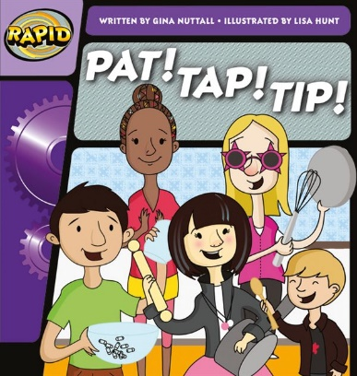The children do a fantastic job practicing their reading books and have been enjoying some chosen favourites for bedtime reading too!

***Approved Reading Lists***

Follow the link to discover approved reading books for children of all ages:

<https://www.booksfortopics.com/early-years>