**English in Hedgehog Class**

Children learn new words as they read. Subconsciously they absorb information on structuring sentences and how to use words and other language elements effectively in their writing and speaking.

Through reading we feed our imaginations, children use the words to create pictures in their mind. While engaged in a story, children imagine how a character is feeling and use that when interacting with others. This helps with their empathy. Understanding how others feel is an important life skill.

English in Hedgehog class is based around sharing stories, often traditional, for example:

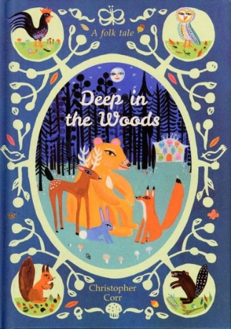Little Red Riding Hood

Hansel & Gretel

We will also be enjoying more contemporary stories such as:

The Gruffalo

Stick Man

Deep in the Woods

We do not just read fiction; woodland creatures will feature in our nonfiction adventures:

