St Gregory’s C E Primary School

New Street, Marnhull, Dorset. DT10 1PZ.
Tel: 01258 820206
e mail: office@stgregorymarnhull.dorset.sch.uk
www.stgregorymarnhull.dorset.sch.uk

Headteacher: Mrs Debbie Field

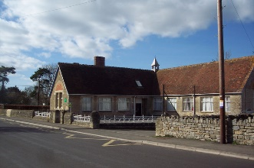

“Where learning has no limits”

Dear Parents/Carers, 4th December 2020

Next Wednesday (9th December) Badgers will be recording our class Christmas performance. If your child has a Christmas jumper please could they bring it into school on this day, thank you. If they don’t have one, they are welcome to bring in a bright coloured jumper from home to wear instead. I have also given them a short section of a story that they will be reading as part of a group. They have been practising at school but if they were able to practise at home a little as well that would be great and would really help their confidence.
Thank you for your support.
Miss Edwards.

