Dear Parent or Carer,

Everyone loves to receive a present at Christmas. But for many vulnerable children and families in Southeast Europe Christmas serves as a reminder of their isolation and poverty. This year the school has decided to support a Christmas box appeal run by FSCI (www.fscinet.org, reg. charity in England & Wales 1107914) to try and help some of the poorest people in Europe to have a more joyful Christmas. We can take action by filling shoeboxes with appropriate items and sending them to people in need and we thought we could find a lower-cost way to help busy families at home and give all our children the chance to experience the joy of giving unconditionally.

Instead of asking each family if they could make a box each we are asking families to send in items to school. Together with this letter is a list of items. Simply choose one of these items (or two, or four, it’s up to you!) to purchase/provide and send them into the school. For example, buying a bulk bag of sweets, such as Haribo, which can then be subdivided between several boxes, is a cost-effective way of contributing. Same goes with the many of the other items on the list.

Not all items have to be new but they should be in good, working condition, so toys that are no longer played with could also be sent in, if they meet these criteria. Please send items into school by Friday 22nd October. We will also need shoeboxes and wrapping paper to cover them with, so don’t throw away the box when you next buy a pair of shoes…

We will spend a day making up the boxes at school. We would aim for each class to make up at least 10 boxes (although it would be fantastic if we could do more than that!). This will ensure that everybody will have the chance to join in preparing a box.

Please let us know if you could join us for the day (or part of) to help wrap the boxes too.

Thank you, Debbie Field

If you would like to support the Christmas box appeal this year then please choose from the list of items below (feel free to donate more than one type of item should you wish!) and send them into school along with an empty shoebox.

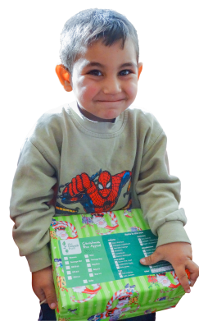
Please also donate £3 (or more) to help cover what it will cost FSCI to ship our boxes to Southeast Europe. Plus we need empty shoeboxes!

- Sweets  - Combs / Hair Accessories | - Pens / Pencils / Cases  - Toothpaste / Brushes
- Small toys | - Small ‘loom’ kits
- Hats / Gloves / Scarves  - Soap / Facecloth | - Jigsaws  - Sticker books
- Balls (tennis, bouncy) | - Colouring books/pens

Deadline to get items and donations into the school:
Friday 22nd October 2021

FSCI (UK) Reg. Charity in England & Wales No. 1170914

