Pupil premium strategy statement

This statement details our school’s use of pupil premium funding to help improve the attainment of our disadvantaged pupils.

It outlines our pupil premium strategy, how we intend to spend the funding in this academic year and the effect that last year’s spending of pupil premium had within our school

School overview
Detail | Data
School name | St Gregory’s Primary
Number of pupils in school | 60
Proportion (%) of pupil premium eligible pupils | 23%
Academic year/years that our current pupil premium strategy plan covers (3 year plans are recommended) | 2021-2024
Date this statement was published | 16 December 2024
Date on which it will be reviewed | December 2025
Statement authorised by | J Farndale
Pupil premium lead | H Shears
Governor / Trustee lead | N Chapman
Funding overview
Detail | Amount
Pupil premium funding allocation this academic year | £7,275
Recovery premium funding allocation this academic year | £1,500
Pupil premium funding carried forward from previous years (enter £0 if not applicable) | £0
Total budget for this academic year  If your school is an academy in a trust that pools this funding, state the amount available to your school this academic year | £9,775

Part A: Pupil premium strategy plan

Statement of intent
When making decisions about using Pupil Premium funding at St Gregory’s, it is important to consider the context of our school and the subsequent challenges faced. Research conducted by EEF should then be used to support decisions around the usefulness of different strategies and their value for money.
Common barriers to learning for disadvantaged children, can be less support at home, weak language and communication skills, lack of confidence, more frequent behaviour difficulties and attendance and punctuality issues. There may also be complex family situations that prevent children from flourishing. The challenges are varied and there is no “one size fits all”.
Our ultimate objectives are:
- To narrow the attainment gap between disadvantaged and non-disadvantaged pupils.
- For all disadvantaged pupils in school to make or exceed nationally expected progress rates.
- To support our children’s health and wellbeing to enable them to access learning at an appropriate level.

We aim to do this through
- Ensuring that high quality teaching and learning opportunities meet the needs of all the pupils
- Ensuring that appropriate provision or adaption is made for pupils who belong to vulnerable groups, where appropriate
- Engaging with our parental body to fully understand the external environment
- Offering ELSA sessions for individual children to support their wellbeing, emotional and behavioural areas

Achieving these objectives:
- Ensuring all teaching is good or better, thus ensuring that the quality first teaching experienced by all children is high.
- Ensuring staff deliver purposeful marking and feedback, so children understand their next steps.
- 1-1 support
- Additional teaching and learning opportunities provided by external agencies, if appropriate
- All our work through the pupil premium will be aimed at accelerating progress, moving children to at least age-related expectations.
- Pupil premium resources are to be used to target able children on Free School Meals to achieve Age Related Expectations
- Support payment for activities, educational visits and residentials. Ensuring children have first-hand experiences to use in their learning in the classroom.

Challenges

This details the key challenges to achievement that we have identified among our disadvantaged pupils.
Challenge number | Detail of challenge
1 | Parental engagement / support at home
2 | Emotional wellbeing
3 | Some of our pupil premium children do not have the rich and varied experiences as non-pupil premium children seem to have - meaning knowledge of the world is limited
4 | Children not having an excitement to read and do not fully engage in process

Intended outcomes
This explains the outcomes we are aiming for by the end of our current strategy plan, and how we will measure whether they have been achieved.
Intended outcome | Success criteria
Pupils make at least expected progress in reading, writing and maths. | Gap will close in progress made between PP and non PP.
Pupils will have a love of reading and be excited by different exploring texts. | Pupil premium children will make good or better progress in reading – this will help vocabulary acquisition and enable them to become life-long readers
Pupils will be regularly accessing home learning – homework / reading / online programmes set by school, supported / encouraged by parents | Parents fully committed to encouraging / supporting their child with home learning – which will in itself help close progress gap  Parents indicate there are strong links between home and school for a wide range of needs  Children are provided with emotional support to raise self-esteem and develop the skills of resilience, independence and perseverance
Pupils access a wide range of enrichment experiences both in and out of school. | Pupil questionnaires / pupil voice reflect enjoyment in school and improved attitudes to learning.  Social skills, independence, perseverance and team work are developed.  Clubs will be offered for our PP children having priority at specific times.  Discounts in line with our charging policy will continue to apply to pupil premium families for all enrichment opportunities to include trips and visits, music lessons, residentials etc
Pupils will have access to regular ELSA as needed sessions in a secure, safe area, with a trusted member of staff – these will be flexible and individualised according to need. | Pupils will be fully engaged in ELSA sessions, and individual plans securely in place. Improvements seen across all areas of school life
PP children continue to feel happy and safe at school and engage with their learning. | - Pupil premium children will engage with the wider life at St Gregory’s by taking on roles of responsibility including pupil council.  - Children’s attendance will remain at national or above because they are happy coming to school  - Pupil voice questionnaires will report that PP children are happy and safe in school

Activity in this academic year

This details how we intend to spend our pupil premium this academic year to address the challenges listed above.

Teaching (for example, CPD, recruitment and retention)
Budgeted cost: £5,000
Activity | Evidence that supports this approach | Challenge number(s) addressed
Implementation of new Enquiry based Curriculum (Curious City) to ensure delivery of engaging curriculum to all learners | An enriched curriculum is vital to ensure all children are motivated by school. Motivation is vital in ensuring all children attend school and want to be the best they can be. | 1, 2, 4
Purchase a new phonics scheme (Little Wandle) and train up staff members to use this | Schools which have a consistent approach achieve good results.  Children need to experience, and be exposed to good quality texts in order to raise expectations and improve their language skills | 1, 4

Targeted academic support (for example, tutoring, one-to-one support structured interventions)
Budgeted cost: £2,275
Activity | Evidence that supports this approach | Challenge number(s) addressed
Timely interventions are put in place including phonics tutoring, precision teaching (spelling and number facts), speech and language interventions | - EEF – oral language interventions consistently show positive impact on learning.  - High quality small group interventions  - Specialist teachers will train up TAs with their work with in school, therefore upskilling them and increasing their knowledge.  - Proven interventions are used, with evidence supporting the development in social skills, speech and language, behaviour and mental health. | 1,2,4
Purchase web-based programs to be used in school and at home.  - Times table Rockstars  - Nessy | EEF toolkit – parental engagement  EEF guide to pupil premium – targeted academic support  EEF – digital technology – clear evidence technology approaches are beneficial for writing and maths practice. | 1,2,4

Wider strategies (for example, related to attendance, behaviour, wellbeing)
Budgeted cost: £2,500
Activity | Evidence that supports this approach | Challenge number(s) addressed
Pupils develop socially and emotionally supporting self-confidence and positive learning behaviours.  1.ELSA and Nurture sessions weekly for identified children  2. ELSA to attend supervision session with EP  3. Well-being resources and mental health resources bought for school including selection of books and games etc  4. On going costs of guinea pigs used for nurture | Taking a coordinated approach to mental health and wellbeing in schools and colleges leads to improved pupil and student emotional health and wellbeing which can help readiness to learn.  To provide children with opportunities to develop self-esteem and confidence in social groups, which is known to have a positive impact on learning.  Children will feel happier being in school we will see an increase in their self-esteem and self confidence in class and school activities.  Pupil surveys reflect greater enjoyment and engagement in school. | 2, 4, 5, 6
Ensure finances are not a barrier to actively taking part in all the school has to offer.  1. 100% contribution towards school trips, including residential | Children and families can feel isolated if not able to take part in all school events  Enrichment activities offer children a context for learning and a stimulus to trigger their interest which can be evidenced in pupil books and data.  EEF – outdoor adventure learning shows positive benefits on academic learning and self -confidence.  Ofsted research (2019) places emphasis on improving cultural capital, particularly for disadvantaged pupils  Learning is contextualised in concrete experiences and language rich environments. | 4, 5, 6
Increased attendance rates for those pupils eligible for PP.  1. Registers monitored regularly  2. Agreed letters sent home if attendance falls below 95%, 90% and 85%  3. Meetings held with parents and attendance challenged  4.Class awards for attendance  5. Funding of breakfast club and or after school club for pp pupils where needed | Children are motivated to be in school and love the competition of the attendance awards.  EEF research found that poor attendance is linked to poor academic attainment across all stages. | 3, 5

Total budgeted cost: £9,775

Part B: Review of outcomes in the previous academic year

Pupil premium strategy outcomes
This details the impact that our pupil premium activity had on pupils in the 2023 to 2024 academic year.
Data

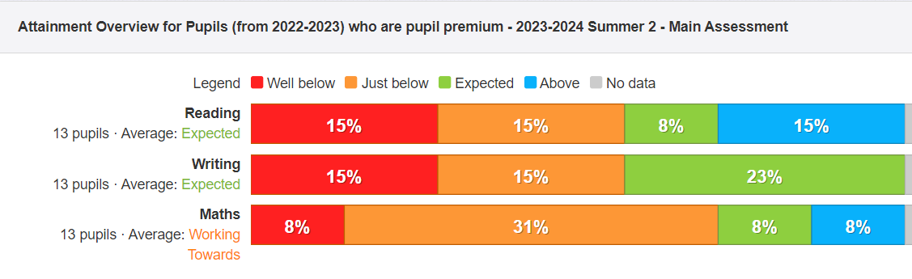
During this academic year we had 13 pupils on PP a significant increase from 9, two years ago.

By the end of the year, we had13 PP pupils, but there was lots of movement between school with these pupils so it is hard to accurately track their progress as many were not with us for the whole year.
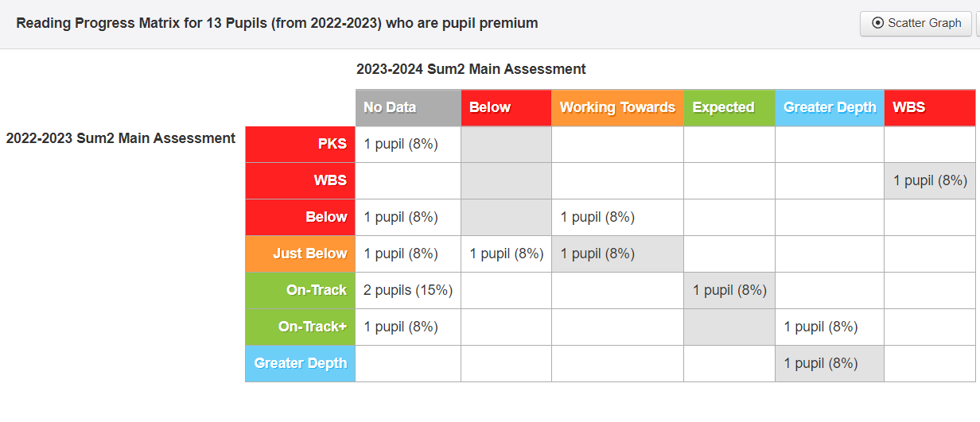
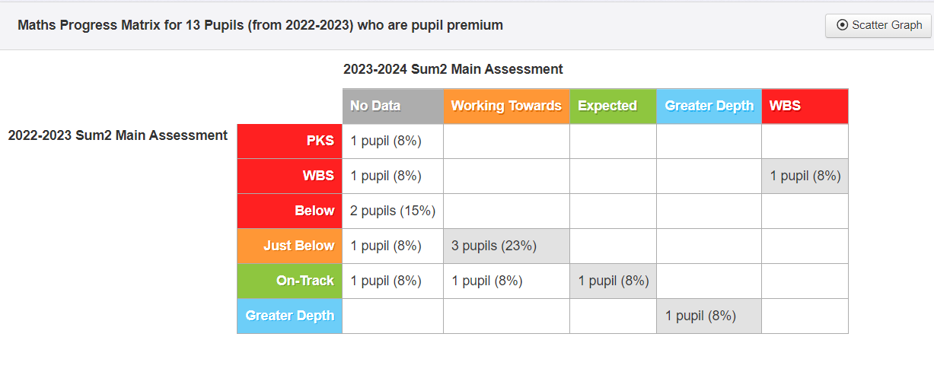

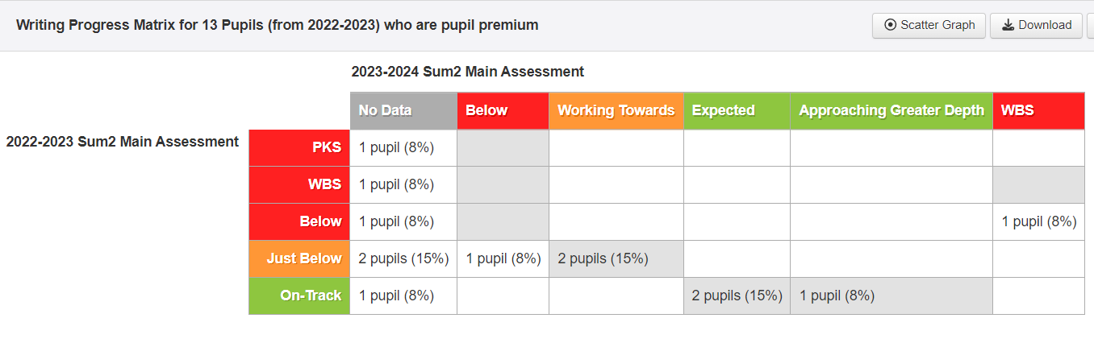

We implemented out new Enquiry based curriculum, Curious City. The children showed high levels of engagement which was also reflected in pupil voice surveys.

PP pupils were fully engaged in a wide range of trips and experiences – examples of these: London theatre trip, residential, sailing. External opportunities to take part in events with other settings - these are all evidenced through photos / pupils’ books / website

FSM children had trips to the Sea-life Centre, Dorchester Town House, M&M theatre and residentials at Cary Camp and Beam house.

FSM children engaged in cultural and many PE activities – see PE funding report,
Opportunities to attend all clubs offered across the school – if externally paid for, cost met by school.

We offered Breakfast / After school care and x4 of these pupils regularly attended, which supported our parents – the costs were covered for this.

Interventions / Support
- Reading – daily reading support to an adult / opportunities to explore books more readily
- Nessy (spelling and reading)
- Phonics – gaps were identified and the pupils who needed it, were given extra phonic support by a TA. Evidence in books showed pupils were starting to apply their phonic knowledge in their writing and using it in their reading to build up words.
- X2 pupils were very early identified as requiring a more personalised curriculum, the class teacher made adaptions in their learning, through resources, support, scaffolding, manipulatives.
- ELSA and Nurture run as needed. 9 PP pupils accessed these over the year. Pupils have the opportunity to speak with an adult, use of a safe space to go to when their emotions have escalated and they need to calm down. We observed a difference in the children when they selected to go to their safe space.
Animals in school:
- Guinea pigs – children de-escalated very quickly when they were able to hold our guinea pigs.

