St Gregory’s C E Primary School

New Street, Marnhull, Dorset. DT10 1PZ.
Tel: 01258 820206
e mail: office@stgregorymarnhull.dorset.sch.uk
www.stgregorymarnhull.dorset.sch.uk

Headteacher: Mrs Debbie Field

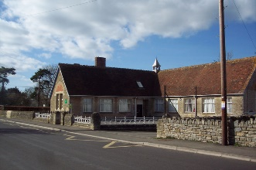

“Where learning has no limits”

17th July 2017
Dear Parents/ Carers

As I said in one of my previous newsletters I have been working with staff to look at the reorganisation of breakfast / after school club. This is to keep it in line with other settings and ensuring that we offer the best for your children during those times.
Mrs. Dunn / Mrs Mogg will continue to run the after school club.
The children in after school club have decided to re-launch it with a new name, which links in really well with our whole school motto / class names / outside area.
‘
Woodland Wonders’
“Where wonderful things happen”

The staff and I thought this was just perfect

The Woodland Wonders After School club will run from September in the hall – where there will be a designated space / furniture / display boards for the sole use of the club. The staff are already planning activities to offer the children, this will include not only inside activities but outside as well.

Woodland Wonders Breakfast club will be in the school kitchen and the Rainbow room next door. Any children not having breakfast will be offered a number of activities to do in the Rainbow room. At 8.40 am all children in this club will be taken out to the playground by staff, where they will be supervised until the whistle goes at 8.50am. Children can arrive from 8.00am. We will run with the present system for breakfast club – which will be monitored during the Autumn term. Mrs. Coling and Mrs Northam will be running the breakfast club.

Please find attached a new booking form for after school club. This will also go on our new website, along with additional club information.

Mrs Dunn / Mrs Mogg will be more than happy to discuss with you any queries you may have.

With my best wishes
Debbie Field

“I have come that they may have life, life in all its’ fullness” John 10:10

